Tilak Maharashtra Vidyapeeth, Pune
Department of Computer Science
----------------------------------------------------------------------------------------------------------------
A PROJECT REPORT

ON

DefendHER-WOMEN SAFETY APP

----------------------------------------------------------------------------------------------------------------

By
SALVIA DSOUZA
ANCHAL TIWARI

Towards The Partial Fulfillment of the
Bachelor of Computer Application

----------------------------------------------------------------------------------------------------------------

[TLFC-0217]
[Mumbai]

Tilak Maharashtra Vidyapeeth, Pune
Department of Computer Science

[2023-2024]

Tilak Maharashtra Vidyapeeth, Pune
Department of Computer Science
----------------------------------------------------------------------------------------------------------------
----------------------------------------------------------------------------------------------------------------

CERTIFICATE

This is to certify that the project
“DefendHER”
Has been satisfactorily completed by

SALVIA DSOUZA
ANCHAL TIWARI

Towards The Partial Fulfillment of the ‘Bachelor of Computer Application’,
For the Academic Year [2023-2024] at [TLFC-0217] Center,
[Mumbai],
Tilak Maharashtra Vidyapeeth, Pune (Department of Computer Science), And it is approved.
----------------------------------------------------------------------------------------------------------------

Project Guide Examiner Head of Department
[TLFC – Mumbai]

Tilak Maharashtra Vidyapeeth, Pune
Department of Computer Science
----------------------------------------------------------------------------------------------------------------

----------------------------------------------------------------------------------------------------------------

ACKNOWLEDGEMENT

With immense pleasure we are presenting “DefendHER Using Android Application” Project report as part of the curriculum of ‘Bachelor of Computer Application’. We wish to thank all the people who gave us unending support.

We express our profound thanks to our Head of Department Mr.“Vaibhav Diwadkar”,
Project Guide Mrs.“Priyanka Sansare” and all those who have indirectly guided and helped us in preparation of this project.

SALVIA DSOUZA
ANCHAL TIWARI

----------------------------------------------------------------------------------------------------------------

Project Synopsis:
Name of the Project:
DefendHer – Women Safety Android App
Front End:
- Android Studio
- Java
Back End:
- Fire base
Software Requirements:
- Android Studio
- Minimum Android Version 7.0
Hardware Requirements:
- Android Smartphone

Project Summary:
DefendHER is an Android Women Safety App that aims at empowering women by providing them with a comprehensive safety solution.As we navigate the digital landscape of safety, DefendHER remains committed to its mission of ensuring the well-being and confidence of every user. It’s key features include Real-Time Tracking, Immediate Assistance through Emergency SOS Button, and Flexibility of SMS Alerts etc. It’s a Digital Guardian and a rapid response system that contributes to overall effectiveness and provides a highlighted security layer. This app would create an environment where women feel safe and confident in every setting.

ABSTRACT

In the modern digital landscape, users frequently experience "digital fragmentation," navigating between a multitude of disparate websites and applications to perform routine tasks such as financial calculations, academic conversions, and casual gaming. Recognizing the inefficiency and friction this causes, this project introduces Smart Hub, a comprehensive, full-stack web application engineered to centralize productivity and social interaction.
Smart Hub is designed as an "all-in-one" utility ecosystem that brings together over 80 meticulously categorized calculators (spanning Finance, Health, Academics, and Engineering), interactive real-time multiplayer games, and a robust social network into one unified portal. The platform guarantees high performance and accessibility across all devices through a responsive, modern glassmorphism user interface powered by Tailwind CSS.
At its core, Smart Hub leverages a robust backend architecture built with Node.js and Express.js, seamlessly connected to a MongoDB database via Mongoose. This allows for secure, persistent user accounts, safeguarded by JSON Web Tokens (JWT) and Bcrypt password hashing. Every calculation performed by a user is automatically saved to a personalized history log, allowing for seamless retrieval of past academic or financial data.
Furthermore, the integration of the Socket.io library elevates the platform from a static utility site to a dynamic social hub. Users can connect using unique "Hub IDs" to protect their privacy, engage in live multiplayer games like Chess and Tic-Tac-Toe, and compete on globally synchronized leaderboards.
Through its combination of diverse utilities, secure data management, and real-time connectivity, Smart Hub successfully demonstrates the power of modern full-stack web development in solving everyday digital inefficiencies, ultimately providing users with a faster, smarter, and unified digital companion.

INDEX
Sr.No | Topic | Page No.
1. | INTRODUCTION  1.1 Concept Brief  1.2 App Overview  1.3 Goals  1.4 Need  1.5 Advantages  1.6 Drawbacks | 12  TO  18
2. | OBJECTIVES  2.1 Inclusivity and accessibility  2.2 Empowerment through education  2.3 Intersectionality with cultural sensitivity. | 19  TO  21
3. | INSIGHTS AND DATA VISUALIZATION  3.1 State-wise Statistics  3.2 Comprehensive Analysis of Women's Safety  3.3 A Data-Driven Exploration of Safety, Policy, and Global  Perspectives  3.4 Crime Against Women Under Indian Penal Code (IPC)  3.5 Women's Safety Concerns: Reported Crimes Analysis | 22  TO  26

4. | TECHNOLOGICAL SPECIFICATIONS  4.1 Software Requirement Specification  4.1.1 A statement of the requirements for the implementation  4.1.2 System Features  4.1.3 Software Quality Attributes  4.2 Overview Of Front End and Back End  4.2.1 Android Overview  4.2.2 Why Android  4.2.3 Android Features  4.2.4 Android Studio  4.2.5 How Does it work?  4.3 Java  4.3.1 Advantages of Java  4.3.2 Who Creates and Maintains Java?  4.3.3 Java Version  4.4 Firebase  4.4.1 Advantages of Firebase  4.4.2 Features of Firebase  4.4.3 Limitations of Firebase  4.5 Firebase Firestore Database  4.5.1 Features of Firebase Firestore Database  4.5.2 Advantages of Firebase Firestore Database  4.5.3 Drawbacks of Firebase Firestore Database | 27  TO  46

5. | SOFTWARE DEVELOPMENT METHODOLOGIES  5.1 Software Development Life Cycle (SDLC)  5.2 SDLC Process  5.3 Phase in the Software Development Life Cycle (SDLC)  5.4 Waterfall Model  5.5 Phases Of Waterfall Model | 47  TO  52
6. | SYSTEM DESIGN  6.1 System Architecture  6.2 Central Components  6.3 Class Diagram  6.4 UseCase Diagram  6.5 Activity Diagram  6.6 Sequence Diagram  6.7 ER Diagram  6.8 DFD Diagram- Level 0  6.9 DFD Diagram- Level 1 | 53  TO  65
7. | MODULES | 66  TO  68
8. | GANTT CHART  8.1 Gantt Chart Table  8.2 Gantt Chart Graph | 69  TO  70
9. | APP PREVIEW  9.1 Onboarding Screen  9.2 Login Page | 71
 | 9.3 Verification Page  9.4 Firebase Database  9.5 HomePage  9.6 Emergency Contact Page  9.7 SMS Alert  9.8 Location  9.9 Helpline  9.10 Self-defence  9.11 Navigation Drawer  9.12 Profile  9.13 Settings | TO  83
10. | FUTURE SCOPE | 84  TO  85
11. | LIMITATION | 86  TO  87
12. | CONCLUSION | 88
13. | REFERENCES | 89  TO  90

LIST OF ABBREVIATIONS

SR NO. | ABBREVIATIONS | FULL FORMS
1. | NCRB | National Crime Records Bureau
2. | SOS | Save Our Souls
3. | SMS | Short Message Service
4. | SDLC | Software Development Life Cycle
5. | UML | Unified Modelling Language
6. | ERD | Entity Relationship Diagram
7. | SRS | Software Requirements Specification
8. | UTA | User Acceptance Testing
9. | DFD | Data Flow Diagram

10. | GPS | Global Positioning System
11. | IPC | Interprocess Communication
12. | JDK | Java Development Kit
13. | IBM | International Business Machines
15. | ML | Machine Learning
16. | FCM | Firebase Cloud Messaging

Introduction

1.1 Concept Brief:
In today’s fast-paced digital ecosystem, efficiency and time management are critical for students, professionals, and everyday users. However, a major bottleneck in digital productivity is "digital fragmentation." users frequently find themselves switching between multiple browser tabs, mobile applications, and standalone software to perform minor daily tasks. For instance, a student might use one website to calculate their gpa, another to convert units, a third to check financial conversions, and yet another entirely different platform to play a quick casual game or chat with a peer.

This constant context-switching not only breaks concentration but also clutters the user experience, leading to password fatigue, fragmented data, and decreased overall productivity. Furthermore, most static utility websites do not offer an integrated way to save calculation history, meaning users often lose track of their previous work the moment they close the tab.

Smart hub conceptualizes a modern solution to this problem by serving as a unified, centralized digital workspace. It brings together over 80 meticulously categorized utility calculators (ranging from academic tools to financial and health trackers), real-time interactive multiplayer games, and a secure social networking module into one cohesive platform. By consolidating these disparate tools into a single ecosystem with a global login, smart hub significantly reduces the friction of modern digital navigation.

Built on a robust full-stack architecture—utilizing node.js, express.js, mongodb, and socket.io—smart hub provides a fast, persistent, and real-time experience. Users can perform complex calculations, instantly retrieve their past query history from a cloud database, and seamlessly invite friends via unique "hub ids" for a quick game of chess or tic-tac-toe, all without ever leaving the application. This project not only aims to enhance daily productivity but also demonstrates the profound capabilities of modern web development in solving everyday digital inconveniences.

1.2 App Overview:
Smart Hub Is A Premium, Full-Stack Productivity And Networking Web Application Designed To Act As A Definitive Digital Companion. Developed Using Modern Web Standards (Html5, Css3, Vanilla Javascript On The Frontend, And A Node.Js/Express Backend), The Application Stands Out By Offering An Expansive Suite Of Tools Wrapped In A Highly Responsive, "Glassmorphism" User Interface Styled With Tailwind Css.
At Its Core, Smart Hub Functions As A Multi-Tool Dashboard. Upon Secure Registration And Login—Facilitated By Json Web Tokens (Jwt) And Bcrypt Password Hashing—Users Are Greeted By A Personalized Workspace. The Platform Is Divided Into Three Primary Modules: The Productivity Suite, The Real-Time Gaming Lobby, And The Social Network.
The Productivity Suite Houses Over 80 Interactive Calculators. These Are Logically Sorted Into Categories Such As Finance, Health & Fitness, Mathematics, Engineering, And Academics. A Standout Feature Of This Suite Is The Automated History Tracking. Every Calculation Performed Is Logged Into The User's Mongodb Profile Via A Restful Api, Allowing For Effortless Retrieval Of Past Data—A Feature Rarely Found In Standard Calculator Applications.
The Real-Time Gaming Lobby Leverages Socket.Io To Provide Instantaneous, Bidirectional Communication Between The Server And Clients. This Enables Users To Engage In Multiplayer Games Like Chess, Connect 4, And Device-Orientation-Based Racing Games With Zero Page Reloads. Game States Are Synchronized Perfectly Across Different Browsers, And Victories Are Recorded On A Globally Synchronized Leaderboard.
The Social Network Introduces The "Hub Id" System. To Protect Privacy, Users Connect With Peers Using A Unique Alphanumeric Identifier Rather Than Searching By Real Names. Once Connected, Friends Can View Each Other's Profiles, Chat, And Invite One Another To Multiplayer Game Sessions.
Finally, An Exclusive Admin Dashboard Provides Platform Administrators With A Hidden Portal To Manage User Accounts, View System Performance Statistics, And Monitor Database Health, Ensuring The Platform Remains Secure And Optimized.

Target Audience:
Smart Hub Is Designed For A Broad And Diverse Demographic, Primarily Targeting:
Students & Academics: Who Require Quick Access To Gpa Calculators, Scientific Converters, And A Reliable Way To Store Their Calculation Histories For Assignments.
Professionals & Freelancers: Who Benefit From Centralized Financial Tools, Tax Calculators, And Productivity Trackers Without Navigating Spam-Filled Third-Party Websites.
Casual Users: Individuals Looking For A Secure, Fast Digital Toolkit That Also Offers Light Entertainment (Multiplayer Games) And Private Networking With Friends.

Mission:
The Mission Of Smart Hub Is To Eliminate Digital Fragmentation By Providing A Unified, High-Performance Web Platform That Empowers Users To Manage Their Daily Computational Tasks, Socialize, And Unwind Interactively, All Within A Single, Secure, And Aesthetically Pleasing Environment.

Vision:
The Vision Of Smart Hub Is To Evolve Into A Comprehensive Digital Operating System Within The Browser—A Platform Where Users Rely On A Single Login To Access An Ever-Expanding Library Of Premium Utilities And Real-Time Social Experiences. Through Continuous Integration Of Modern Apis And Robust Backend Scaling, Smart Hub Aims To Set A New Standard For Web-Based Utility Suites, Proving That Complex Productivity Tools And Casual Social Gaming Can Coexist Seamlessly Without Compromising Performance Or Privacy.
1.3 Goals:
The Development And Deployment Of The Smart Hub Platform Are Driven By Several Primary Goals, Aimed At Addressing Specific User Pain Points And Demonstrating Advanced Software Engineering Techniques.
Consolidation Of Digital Utilities: The Primary Goal Is To Curate And Consolidate An Extensive Library Of Over 80+ Everyday Utilities Into One Accessible Dashboard. By Categorizing These Tools Intuitively (E.G., Finance, Health, Academics), The Platform Aims To Save Users The Time They Would Otherwise Spend Searching For Standalone Applications On Search Engines.
Implementation Of Persistent Data Tracking: Unlike Static Utility Websites That Discard Data Once The Tab Is Closed, A Major Goal Of Smart Hub Is To Provide Data Persistence. By Leveraging Mongodb And Mongoose, The System Automatically Saves A User's Calculation History, Allowing Them To Review Past Financial Planning, Health Metrics, Or Academic Conversions At Any Time.
Facilitating Real-Time Social Interaction: Another Core Goal Is To Elevate The Platform From A Single-Player Tool To A Dynamic Social Environment. By Implementing Websockets (Socket.Io), The Goal Is To Enable Seamless, Real-Time Multiplayer Gaming And Instant Notifications, Allowing Users To Connect And Compete Without Latency Or Page Refreshes.
Ensuring Top-Tier Security And Privacy: Given That Users Generate Persistent Accounts And Store Personal Calculation Data, Establishing A Highly Secure Environment Is Paramount. The Goal Is To Enforce Strict Authentication Protocols Using Jwt (Json Web Tokens), Securely Hash Passwords Using Bcrypt, And Protect User Identity By Implementing The "Hub Id" Friend System, Which Masks Personal Identifiable Information During Friend Discovery.

1.4 Need:
The Necessity For The Smart Hub Web Application Stems From The Inefficiencies Inherent In The Current State Of Everyday Digital Tool Consumption. Despite The Internet Being Saturated With Calculators, Games, And Social Tools, Their Disjointed Nature Creates Significant Friction For End-Users.
➢ Combating Context Switching: In Cognitive Psychology And Productivity Research, "Context Switching"—The Act Of Jumping Between Different Tasks, Tabs, Or Applications—Is Proven To Severely Degrade Focus And Increase Mental Fatigue. A User Calculating A Loan On One Website, Converting Currency On Another, And Logging Into A Separate App To Message A Friend Wastes Valuable Time. Smart Hub Is Needed To Provide A Single, Focused Environment Where All These Micro-Tasks Can Be Executed Sequentially Without Altering The User's Digital Context.
➢ The Need For Reliable, Ad-Free Utilities: Many Standalone Calculator Websites Are Heavily Monetized, Cluttered With Intrusive Advertisements, And Possess Poor, Outdated User Interfaces. There Is A Pressing Need For A Premium, Clean, And Ad-Free Utility Suite (Utilizing Modern Ui/Ux Principles Like Tailwind's Glassmorphism) That Respects The User's Experience And Screen Real Estate.
➢ Persistent Personal Data: Standard Utility Sites Lack User Accounts, Meaning Temporary Data Is Instantly Lost. If A User Spends Twenty Minutes Calculating Complex Mortgage Variations, Closing The Browser Erases That Effort. Smart Hub Fulfills The Critical Need For An Automated, Cloud-Synced History Log That Acts As A Digital Ledger For A User's Productivity.
➢ Safe And Private Micro-Socializing: Mainstream Social Networks Are Often Overwhelming And Privacy-Invasive. There Is A Niche Need For "Micro-Social" Platforms Where Users Can Connect Strictly With Close Peers For Light Competitive Gaming Or Quick Chats. Smart Hub’s Hub Id System Fulfills This By Requiring Users To Actively Share Their Id To Connect, Preventing Unsolicited Discovery And Spam.

1.5 Advantages:
Unmatched Convenience And Accessibility: The Most Prominent Advantage Of Smart Hub Is The Sheer Convenience It Offers. By Hosting Over 80+ Tools In One Location, Users Dramatically Reduce The Time Spent Searching For And Validating Third-Party Tools. Because It Is A Responsive Web Application, It Requires No Downloads Or Installations, Making It Instantly Accessible From Desktops, Tablets, And Smartphones.
Real-Time Data Synchronization: Through The Integration Of Socket.Io, Smart Hub Boasts Real-Time Capabilities That Elevate The User Experience. Whether It Is Updating A Multiplayer Game Of Chess In Milliseconds, Reflecting A New High Score On The Global Leaderboard, Or Receiving A Friend Request Instantly, The Platform Feels Alive And Highly Responsive.
Secure And Persistent Cloud Storage: Using Mongodb, All User Data—From Personalized Settings (Like Dark Mode Preferences) To Detailed Calculation Histories—Is Stored Securely In The Cloud. This Provides The Distinct Advantage Of Cross-Device Continuity. A User Can Perform A Calculation On Their Mobile Phone During A Commute And Review The Exact Result On Their Laptop Later In The Day.
Modern, Premium User Interface: Built With Tailwind Css, The Platform Utilizes A Sleek, "Glassmorphism" Aesthetic With Intuitive Navigation And Customizable Theming. This Clean Design Reduces Cognitive Load, Making Complex Calculators Less Intimidating And More User-Friendly Compared To Traditional, Cluttered Utility Websites.
Centralized Administrative Control: The Inclusion Of A Dedicated Admin Dashboard Provides An Operational Advantage. Administrators Can Seamlessly Manage User Permissions, Monitor System Health, View Platform Analytics, And Troubleshoot Issues From A Single, Protected Interface, Ensuring High Platform Reliability.
1.6 Drawbacks:
Total Dependence On Network Connectivity: Because Smart Hub Relies Heavily On Cloud-Based Database Queries (Mongodb) And Real-Time Websocket Connections (Socket.Io) For Core Functionalities Like Logging History And Multiplayer Gaming, It Requires A Continuous And Stable Internet Connection. If The User Loses Network Connectivity, The Dynamic Features Of The App Will Fail To Synchronize, Rendering Games Unplayable And Preventing Data From Saving.
Server Load And Scalability Challenges: Real-Time Bidirectional Communication Via Websockets Consumes Significantly More Server Resources Than Standard Http Requests. If Thousands Of Users Are Simultaneously Playing Multiplayer Games And Broadcasting State Changes, It Could Put A Heavy Load On The Node.Js Express Server. Scaling Such A Stateful Architecture Requires Complex Load-Balancing Strategies (Like Redis Adapters For Socket.Io) Which Adds Overhead To Maintenance.
Overwhelming Feature Density For Simple Users: While Having 80+ Calculators Is An Advantage For Power Users, It Can Be Overwhelming For Individuals Who Only Require A Simple Standard Calculator. Despite Categorization, The Sheer Volume Of Tools And The Inclusion Of Social And Gaming Elements Might Distract Users Who Prefer Minimalist, Single-Purpose Applications.
Database Dependency (Vendor Lock-In): The Application Is Heavily Reliant On Mongodb And The Mongoose Odm For Structuring Data (User Schemas, History Schemas). If A Decision Is Made In The Future To Migrate To A Relational Sql Database, It Would Require A Significant Rewrite Of The Backend Logic, Models, And Api Endpoints, Presenting A Substantial Technical Hurdle.

2. Objectives
The Development Of The Smart Hub Platform Was Guided By A Set Of Concrete, Measurable Objectives Designed To Push The Boundaries Of Standard Web Applications. Instead Of Building A Simple Static Website, The Objective Was To Engineer A Complex, Stateful, Full-Stack Application That Genuinely Improves The User's Digital Workflow.
By Combining Utility, Security, And Social Interaction, The Project Aims To Serve As A Comprehensive Demonstration Of Proficiency In Modern Web Technologies, Specifically The Mern-Like Stack (Using Vanilla Js/Html In Place Of React) Combined With Real-Time Networking.
The Objectives Of Smart Hub Are Categorized Into Three Fundamental Pillars:
Centralization Of Utilities
Seamless User Experience And Performance
Real-Time Interaction And Social Networking
Each Of These Pillars Focuses On Solving A Specific Problem Related To Digital Fragmentation, User Engagement, And Data Persistence, Ensuring The Final Product Is Not Only Functional But Highly Scalable And User-Centric.
2.1 Centralization Of Utilities:
➢ The Primary Objective Is To Engineer A Highly Organized, Searchable Repository Of Over 80+ Calculators And Conversion Tools. This Requires Building A Scalable Frontend Architecture Where Scripts Are Modularized, Ensuring That Loading Dozens Of Utility Logic Files Does Not Bottleneck The Initial Page Load.
➢ To Implement A Robust Backend Api (Using Express.Js) That Seamlessly Intercepts The Results Generated By These Frontend Utilities And Securely Writes Them To A Mongodb Database. This Fulfills The Objective Of Creating A Persistent "Calculation History" Ledger For Every Individual User.
➢ By Centralizing These Tools, The Platform Successfully Aims To Keep Users Within A Single Ecosystem, Thereby Increasing User Retention And Providing A Comprehensive Digital Toolkit That Satisfies Academic, Financial, And Personal Health Tracking Needs Under One Roof.

2.2 Seamless User Experience And Performance:
➢ To Deliver A Visually Striking And Highly Intuitive User Interface (Ui) Utilizing Tailwind Css. The Objective Is To Utilize Advanced Css Techniques, Such As Glassmorphism, Responsive Css Grid/Flexbox Layouts, And Dark-Mode Toggles, To Provide A Premium Look And Feel Across All Devices (Mobile, Tablet, Desktop).
➢ To Ensure Optimal Client-Side Performance. Despite The Large Number Of Features, The Objective Is To Write Clean, Vanilla Javascript Manipulating The Document Object Model (Dom) Directly. This Avoids The Bloat Of Heavy Frontend Frameworks For Simple Calculations, Ensuring Rapid Execution Of Math Logic.
➢ To Construct A Secure Environment That Users Trust. Implementing Json Web Tokens (Jwt) For Session Management And Bcrypt For Password Encryption Ensures That The User's Transition From Login To Accessing Private Dashboards Is Both Frictionless And Protected Against Common Web Vulnerabilities.
2.3 Real-Time Interaction And Social Networking:
➢ To Break The Paradigm Of Solitary Productivity Apps By Integrating A Real-Time Social Networking Module. The Objective Is To Allow Users To Generate Unique, Alphanumeric "Hub Ids", Enabling Them To Add Friends And Build A Private Network Without Exposing Sensitive Personal Data Like Phone Numbers Or Email Addresses.
➢ To Implement And Master Websockets Utilizing The Socket.Io Library. The Objective Here Is To Build A Bidirectional Event-Driven Architecture Where Server And Client Can Push And Pull Data Instantly. This Is Crucial For Enabling The Platform’s Multiplayer Web Games, Such As Chess And Tic-Tac-Toe.
➢ To Create A Globally Synchronized State Management System. When A User Wins A Game, The Backend Must Instantly Update Their Score In The Mongodb Database And Emit An Event To Update The Global Leaderboard Across All Connected Clients Simultaneously. This Objective Ensures The Platform Feels Active, Competitive, And Highly Engaging.
Ultimately, Achieving These Objectives Transforms Smart Hub From A Simple Collection Of Web Pages Into A "Living," Stateful Application That Perfectly Balances Personal Productivity With Real-Time Digital Socialization.

3. INSIGHTS AND DATA VISUALIZATION

3.1 State-wise Statistics
In India, violence against women continues to be a widespread and deeply ingrained problem that has a variety of social, psychological, and physical aspects. Gender-based violence episodes continue to occur despite legislative measures and cultural initiatives. These incidents can take many different forms, including domestic abuse, sexual assault, harassment, violence tied to dowries, and human trafficking. These crimes perpetuate a culture of fear and insecurity among women by causing not just acute bodily pain but also long-lasting psychological wounds. Safety concerns loom large, especially in public spaces where women often face harassment and intimidation, hindering their freedom of movement and participation in social and economic activities. Addressing these safety concerns demands a multi-faceted approach, encompassing robust legal frameworks, enhanced law enforcement measures, community engagement, education, and empowerment initiatives. A society where women may live fearlessly, with dignity and respect, and with equal opportunity for everyone becomes essential as we face the ugly reality of gender-based violence in India.

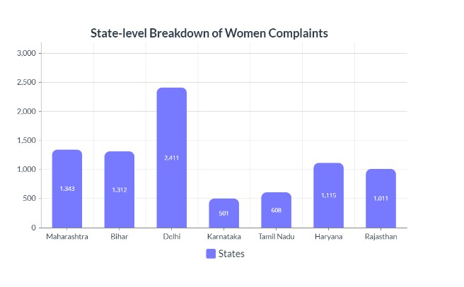
Figure 3.1: State-level Women Complaints Statistics

3.2 Comprehensive Analysis of Women's Safety: Insights, Statistics, and Data Visualization"

Crime Rates and Trends :
India's crime statistics and patterns paint a complicated and alarming picture, especially when it comes to issues that impact women's safety. Attack, harassment, domestic abuse, and stalking occurrences continue despite attempts to reduce gender-based violence. Regional differences in frequency and changes in crime rates over time are shown by statistical analysis. Underreporting, which hides the actual scope of the issue, is still a major obstacle.

Safety Perception Surveys :
In India, studies on safety perception are essential for comprehending women's experiences and worries about safety in different contexts. These studies capture the many situations in which women traverse their everyday lives, including public locations, workplaces, educational institutions, and home regions. Such surveys provide valuable insights into how secure or vulnerable women feel in various settings, pointing out areas that need further investigation and support. Women's feelings of safety are influenced by several factors, including illumination, infrastructure, law enforcement presence, and social attitudes towards gender-based violence.

Gender-based Violence Statistics:
India's gender-based violence statistics present a horrifying image of widespread and systemic abuse against women. The rate of sexual assault, femicide, and intimate partner violence is still frighteningly high despite government initiatives and community efforts. Underreporting, which is caused by things like social shame and fear of harm, is one of the big problems. In order to address gender-based violence in India and build safer and more equal settings for all people, it is necessary to implement comprehensive legislative frameworks, policy initiatives, and a radical change in cultural attitudes and gender norms.

3.3 A Data-Driven Exploration of Safety, Policy, and Global Perspectives

Legal and Policy Analysis:
The legal and policy landscape surrounding women's safety is complex and constantly evolving. Some key areas of focus include:
- Strengthening legislation
- Improved law enforcement practices
- Community-based initiatives

Social Media and Online Harassment:
The explosion of social media has created a double-edged sword for women's safety. Platforms provide chances for connection and self-expression, but they also create new pathways for online harassment and abuse. Women are disproportionately subjected to hostile comments, threats, and stalking. This can have a severe detrimental influence on their mental health, limiting their online activity. To make the online environment safer for women, social media businesses must develop tougher policies against online harassment, invest in improved content filtering, and provide users with reporting mechanisms.

International Comparisons:
When it comes to women's safety, international comparisons provide insight into best practices and opportunities for growth. Countries with high rankings frequently put emphasis on factors such as:
- Social Safety Nets
- Gender equality.
- Invest in preventative measures. • Strong legislative frameworks

3.4 Crime Against Women Under Indian Penal Code (IPC)

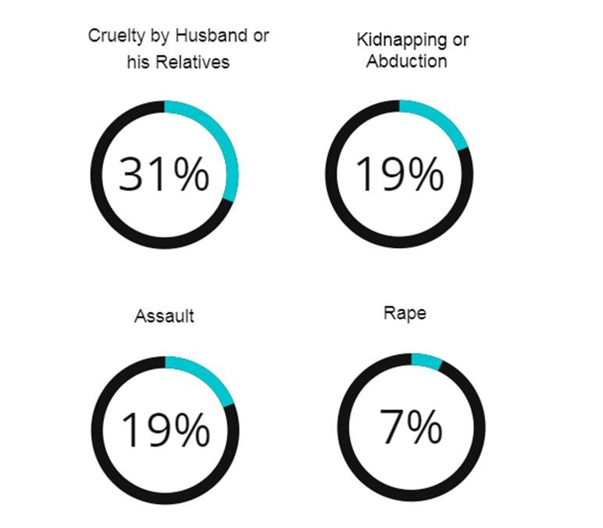

Figure 3.2: Women's Crime Rates: Indian Penal Code (IPC) Offenses

It sheds light on the widespread horrific crimes against women under the Indian Penal Code (IPC) .The most common offenses included cases of 'cruelty by the husband or his relatives', accounting for 31.4% of the reported cases, highlighting women's permanent vulnerability in the family setting and then 'kidnapping and abduction of women', figures for 19.2% of the cases, 'Assault on Women with Outrage Her Modesty' stands as another notable concern, representing 18.7% of reported incidents occur highlighting the ongoing challenges of preventing sexual harassment and violence against women.
The report highlights the severity of 'rape', accounting for 7.1% of cases. These statistics need resources a complete immediately to prevent gender-based violence, ensure access to justice and promote that society emphasizes where women can live free from fear and exploitation.

3.5 Women's Safety Concerns: Reported Crimes Analysis

According to the report, a considerable majority of crimes against women under the Indian
Penal Code (IPC) involve 'Cruelty by Husband or His Relatives' (31.4%), 'Kidnapping and
Abduction of Women' (19.2%), 'Assault on Women with Intent to Outrage her Modesty' (18.7%), and 'Rape' (7.1%). The crime rate per lakh women population increased to 66.4 in 2022 from 64.5 in 2021.

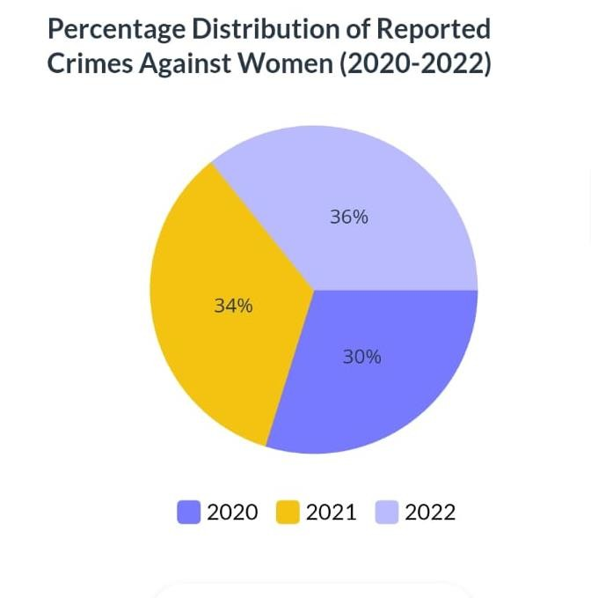

Figure 3.3: Crimes reported against women 2020-2022

- TECHNOLOGICAL SPECIFICATIONS

4.1 Software Requirement Specification:

The Software Requirements Specification (SRS) serves as the cornerstone for your Android application's development journey using Android Studio. This crucial document, meticulously crafted during the analysis phase, defines the application's functionalities, performance expectations, and target audience. A well-defined SRS starts with a clear vision, outlining the application's purpose, its intended users (both technically savvy and those new to technology), and the specific problems it aims to solve. Data handling becomes a key consideration, detailing the type of data the application will work with, its storage needs local or remote on servers, and how this data flows throughout the application.

Functionality takes centre stage as user stories and use cases are defined. User stories paint a picture of how users will interact with the application to achieve specific goals, while use cases goes deeper into concrete scenarios showcasing these interactions. Functional requirements become the building blocks, meticulously listing all the functionalities the application must provide. These requirements detail inputs, outputs, and the expected behaviour of each feature. However, defining what the application does is just one piece of the puzzle. The SRS also establishes validation criteria, essentially the success metrics foreach functionality. In order know if a particular feature is working as intended, this is where acceptance criteria and testing strategies come into play.

Acceptance criteria define the benchmarks for each feature, while the testing strategy outlines a comprehensive plan for evaluating the application's performance. Unit testing ensures individual components function correctly, integration testing verifies how these components work together seamlessly, and user acceptance testing (UAT) brings the user's perspective to the table, ensuring the application delivers a positive user experience.

But when it comes to Android development, the SRS takes on an additional layer of complexity. Specifying the minimum and target Android versions the application will support becomes crucial. After all, you want your application to reach as many users as possible while maintaining functionality. Similarly, any specific hardware or software requirements, like camera access or sensor support, need to be clearly defined. The user interface (UI) also plays a vital role. The SRS should outline the application's visual style, whether it adheres to Android's Material Design principles for a familiar and consistent user experience, or if it adopts a custom design approach.

The importance of a clear and concise Software Requirement Specification cannot be overstated. By meticulously defining these aspects and fostering open communication with stakeholders, developers, designers, and clients, you can significantly reduce misunderstandings later in the development process. A well-defined Software Requirement Specification translates into improved project management, allowing for better planning, estimation, and resource allocation. Furthermore, clear requirements serve as a guidepost for developing a comprehensive testing strategy, ensuring the application functions as intended and delivers a valuable experience for your users. Remember, the Software Requirement Specification is a living document, and as the project progresses and user feedback is incorporated, the Software Requirement Specification may need to be revisited and updated to reflect these valuable insights.

4.1.1 A statement of the requirements for the implementation:
Specifications are additionally used as a reference point for product implementation. In fact, the ultimate purpose of implementation is to create a product that requires specifications. Thus, implementers use specifications during design to make design decisions and during verification to ensure that the implementation corresponds with the specifications.

4.1.2 System Features:

- Emergency Contacts:
These are people or groups you have designated as the first people to call in an emergency. These could be neighbors, friends, relatives, or emergency services like the fire department, police, or ambulance. Keeping a list of emergency contacts close at hand will help guarantee that the right action is taken as soon as necessary and speed up the process of seeking aid when needed.

- Location Tracking:
Many female safety apps offer real-time GPS tracking, allowing designated contacts or authorities to locate the user in an emergency. This feature can be especially useful for individuals traveling alone or in unfamiliar environments.

- Secure routes and Location Sharing:
Some apps allow you to coordinate and share safe routes with trusted contacts. Users can share their real-time location with friends or family members as they travel, allowing them to track their progress and take immediate action if needed.

- Safety tips and resources:
Women’s safety apps often provide educational materials on personal safety, self-defense techniques, and information about local support services and helplines. These resources provide users with users can acquire the knowledge and tools to protect themselves and seek help when needed.

4.1.3 Software Quality Attributes:

Software quality attributes are measurable or testable characteristics that indicate how well a software system meets the needs of its users.
Software quality qualities pose major concerns during the development and testing stages of software development. These characteristics go beyond the software's fundamental functionality and include features that affect user experience, system performance, maintainability, and overall effectiveness. By focusing on these quality attributes, developers may ensure that their software is not only functional, but also dependable, safe, useable, and customised to the specific demands of its users.

1. Security:
A Women's Safety App relies heavily on security measures. Without strong security measures, the app's primary function of protecting users in vulnerable situations is compromised. Sensitive user data, such as names, phone numbers, emergency contact information, and even medical information requires the highest security. Encryption at rest and in transit protects this information from unauthorized access, even in the case of a database breach. Strong password hashing techniques are critical for preventing brute-force attacks on user credentials.
Access controls with multi-factor authentication provide an additional layer of protection, guaranteeing that only authorized users have access to the app and its features. It is ensured that these vulnerabilities are fixed before they may be exploited by promptly delivering security updates. Throughout the development process, using secure coding methods reduces the possibility of creating vulnerabilities in the first place. Maintaining security is a continuous effort that requires steadfast attention.

2.Usability:
The building block of an effective women's safety app is usability. An app that is quick to open, easy to use, and intuitive is what a user needs in an emergency. It might be quite harmful to struggle with a complicated interface or confusing functionalities. This is how giving usability top priority empowers users:
The interface should have few words, easily recognizable icons, and be tidy and uncluttered.
It should be easy to reach large, prominent buttons, such as the SOS button, that may be used to initiate alarms with little effort.
Even in stressful situations, locating important elements like resource lists, emergency contacts, and incident reporting should be simple. Quick access to the app's features is ensured via simple and logical navigation.
Ultimately, a user-friendly Women's Safety App becomes an extension of a user's safety net, providing comfort and confidence in potentially life-threatening situations.

- Reliability:
The foundation of dependability in a women's safety app is reliability. The software application must always work well when a user who is in danger uses it for assistance. Downtime at a crucial delay could have disastrous effects. Encouraging reliability gives users the following benefits:

Smooth operation is ensured by routine maintenance and performance monitoring. Precise user data, location data, and emergency contact information are key. Data integrity is maintained via strong error handling and validation procedures. When a user initiates an alert, each second matters. Notifications should be sent out quickly and alerts should be processed quickly by the app. Achieving quick reaction times requires optimizing server performance and communication connections. Users can depend on the app's reliability and they can gain a crucial sense of security and confidence in its ability to protect them.

- Availability:
"Availability" as a software quality attribute in the context of a women's safety app refers to the dependability and accessibility of the application's services whenever they are needed. It guarantees that the application is always functional and responsive to user demands, particularly in urgent circumstances.

Availability is important for women's safety apps because it guarantees uninterrupted access to emergency services like location sharing, SOS alerts, and contact notifications. This characteristic includes things like feature responsiveness, network dependability, and server uptime.
- Accuracy:
Accuracy pertains to the accurate and consistent operation of its functions, particularly location tracking, emergency detection, and alerting methods. Accurate location monitoring guarantees that the application can locate the user's exact location, allowing for immediate aid from emergency personnel. The software must accurately identify true emergency situations, reducing false alarms while quickly identifying legitimate dangers. Furthermore, reliable alerting methods ensure that emergency notifications are delivered to selected contacts or authorities as soon as possible, delivering critical information for prompt and effective response.
Overall, accuracy is critical to ensuring that the women's safety app achieves its primary goal of increasing users' safety and security, maintaining accuracy is essential for smooth functioning of the application and enhancing safety.

- Maintainability :

A women's safety app's maintainability, as a software quality attribute, is how easily it can be updated, changed, and maintained over time. It covers a wide range of topics, including modular design, readability of the code, high-quality documentation, and the capacity to make modifications without unforeseen impacts.

Maintainability is essential for a women's safety app to be able to adjust to changing user needs, technology improvements, and security specifications. It enables developers to quickly and effectively add new features, correct errors, and fix vulnerabilities.
Maintainability ensures the long-term viability and effectiveness of a women's safety app by enabling it to evolve and remain relevant in an ever-changing environment.

4.2 Overview Of Front End and Back End: -

    - Front End:- Android Studio, Java.
    - Back End:- Firebase.
    - Database System:- Firebase Firestore Database.

4.2.1 Android Overview: -
Android reigns supreme in the mobile world, holding the title of the best-selling operating system for smartphones and tablets.
This open-source, Linux-based platform powers billions of devices globally.
Developed by a consortium led by Google, Android offers a unified approach to app development, allowing developers to code once and deploy their creations across a vast range of Android devices.
This focus on compatibility makes it an attractive choice for developers.
Beyond app development, Android boasts a user-friendly interface, customizable features, and access to the ever-growing Google Play Store, brimming with apps, games, and other digital content.
This combination of developer-friendly tools, user customizability, and a rich app ecosystem has solidified Android's position as the dominant force in the mobile landscape.

4.2.2 Why Android?
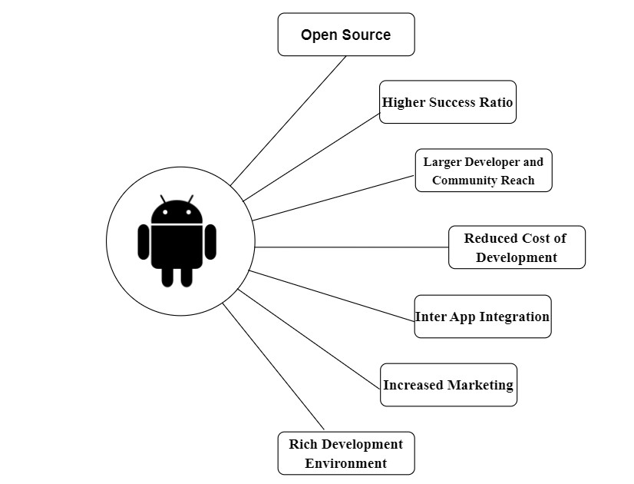

Figure 4: Benefits Android
4.2.3 Android Featues:
Beautiful UI
Android OS basic screen provides a beautiful and intuitive user interface.

Storage
SQLite, a lightweight relational database, is used for data storage purposes.

Web browser
Based on the open-source WebKit layout engine, coupled with Chrome's V8 JavaScript engine supporting HTML5 and CSS3.

Multi-touch
Android has native support for multi-touch which was initially made available in handsets such as the HTC Hero.

Multi-tasking
User can jump from one task to another and same time various application can run simultaneously.

4.2.4 Android Studio:
- Android Studio is a specialized IDE tailored for creating Android applications.

- Android Studio is built on top of JetBrains' IntelliJ IDEA software, which provides a robust and feature-rich development environment.

- It provides a powerful code editor with features like syntax highlighting, code completion, and refactoring tools to enhance productivity.

- Android Studio includes a visual layout editor that allows developers to design app interfaces visually using drag-and-drop components.

- It comes bundled with an Android emulator that enables developers to test their apps on virtual Android devices with different configurations.

- Android Studio offers a comprehensive set of tools for designing, building, and testing Android applications.

4.2.5 How Does it work?
Android Studio is a powerful tool for creating Android apps. It's like a one-stop shop, where you can do everything from writing code (with helpful features like syntax highlighting and debugging tools) to designing the user interface (using drag-and-drop tools and a live preview). It even manages the app's resources and integrates with building and testing systems. This allows you to code the app's logic, build its visual appearance, and test it on virtual devices or your own phone - all within a single environment. For more advanced users, Android Studio offers even more features, like performance optimization tools, cloud integration options, and access to a vast library of pre-built functionalities. In short, Android Studio empowers you to develop your mobile app from start to finish.
4.3 Java:
Java is a powerhouse programming language widely used for building a variety of applications. Imagine it as a versatile tool for crafting software – from the web applications you use daily to the mobile apps on your phone.
Java boasts several key features: it's object-oriented, meaning it organizes code using realworld concepts; it's designed to be portable, allowing code to run on different computer systems; and it prioritizes security, making it a trusted choice for developers.
This combination of features makes Java a popular language for building everything from enterprise software and big data applications to mobile games and even the software behind many websites.

4.3.1 Advantages of Java:

Write Once, Run Anywhere (WORA): Java code is compiled into a bytecode format that can run on any platform with a Java Virtual Machine (JVM). This eliminates the need to rewrite code for different operating systems.
Object-Oriented: Java is an object-oriented programming language, allowing developers to create modular and reusable code components, promoting cleaner and more maintainable applications.
Secure: Java enforces strong memory management and type checking, reducing the risk of security vulnerabilities compared to languages with manual memory management.
Large and Active Community: Java boasts a vast and supportive community of developers, providing ample resources, libraries, and forums for learning and troubleshooting.
Simple and Easy to Learn: Java has a relatively easy-to-understand syntax, making it a good starting point for new programmers.

Rich Ecosystem of Libraries and Frameworks: Java benefits from a wide range of readily available libraries and frameworks that offer pre-built functionalities for various tasks, accelerating development.
Mature and Stable: With over two decades of development, Java is a mature and stable language, ensuring reliable performance for enterprise applications.
Multithreaded: Java supports multithreading, enabling applications to handle multiple tasks simultaneously, improving responsiveness and performance.

4.3.2 Who Creates and Maintains Java?
Java's creation story involves a joint effort. Sun Microsystems initially developed Java in the 1990s, but after their acquisition by Oracle in 2010, Oracle now owns the official Java trademark. However, the language's development isn't a one-man show.
The OpenJDK community, a group including Oracle, IBM, and many other developers, collaboratively contributes to Java's evolution.
So, while Oracle has the final say on the official Java platform, the vibrant OpenJDK community plays a crucial role in shaping Java's future.

4.3.3 Java Version:

The world of Java isn't static - new versions are released periodically. These updates introduce new features, improve performance, and often address security concerns.
Think of them as upgrades to your favourite software, constantly enhancing Java's capabilities.
There are two main branches: Long Term Support (LTS) versions offering extended support for critical applications, and non-LTS versions that introduce cutting-edge features for those willing to adopt the latest advancements.

➢ Long Term Support (LTS) Versions:
- Prioritize stability and extended support (several years).
- Ideal for critical applications requiring reliability.
- Imagine them as dependable workhorses.
➢ Non-LTS Versions:
    - Focus on cutting-edge features and functionalities.
    - Cater to developers seeking the latest advancements.
    - Think of them as high-performance race cars.
    - Typically have shorter support lifespans.

4.4 Firebase:-
Firebase isn't just a single tool, it's a developer's toolbox for building web and mobile apps. Imagine it as a suite of services offered by Google, all designed to streamline the development process and enhance your app's functionality. Firebase offers various features like databases for storing user data, user authentication to manage logins, and hosting services to store your app's code and content. It even throws in some bonus features like built-in analytics to understand user behavior and machine learning tools to add cool functionalities like image recognition. By providing pre-built solutions for common tasks, Firebase empowers developers to focus on what matters most: creating engaging and innovative apps.

4.4.1 Advantages of Firebase:
Streamlined Development: Firebase offers pre-built solutions for common tasks like databases, authentication, and hosting, allowing developers to focus on creating unique app features and functionalities rather than building everything from scratch.
Simplified User Authentication: Firebase removes the complexity of managing user logins and signups. With built-in features, users can sign in using their email, password, or social media accounts, eliminating the need for developers to code complex authentication systems from scratch.
Scalable Cloud Databases: Firebase provides flexible and scalable databases that grow alongside your app's user base. You can choose from various options like Realtime Database for real-time data synchronization or Cloud Firestore for structured data storage.
Actionable App Analytics: Firebase Analytics empowers you to understand how users interact with your app. You can track user engagement, identify areas for improvement, and measure the effectiveness of your marketing campaigns.
Effortless Cloud Functions: Firebase Cloud Functions let you write server-side code that executes in response to events triggered within your app. This eliminates the need to manage your own servers for functionalities like sending notifications or processing data..

 | DefendHER- Women Safety Android Application
4.4.2  •  •  •  •  • | Features of Firebase: -  Firebase Features: A Developer's Toolkit for Building Powerful Apps  Firebase by Google empowers developers with a comprehensive suite of tools and services to streamline mobile and web app development. Here's a breakdown of some of its key features:  Databases:  - Realtime Database: Stores and synchronizes data across devices in realtime, ideal for collaborative apps or live updates.  - Cloud Firestore: Offers a flexible document-oriented database for structured data storage, perfect for managing user profiles or game progress.  Authentication:  - Email/Password: Enables user login with email addresses and passwords, providing a secure and familiar login method.  - Social Sign-In: Simplifies user registration by allowing logins through popular social media accounts like Google or Facebook.  Hosting:  - Static Hosting: Hosts static web app content like HTML, CSS, and JavaScript files, ensuring fast and reliable delivery.  - Cloud Storage: Provides a secure and scalable platform for storing and managing other app assets like images, videos, and audio files.  40

 | DefendHER- Women Safety Android Application
•  •  • | Cloud Functions:  - Serverless Backend: Allows developers to write server-side code that executes in response to events triggered in the app, eliminating the need for managing separate servers.  - Scalable Functionality: Handles tasks like sending notifications, processing data, or interacting with external services efficiently.  - Analytics:  - User Behaviour Tracking: Provides insights into user engagement, app usage patterns, and crash reports, allowing for data-driven app improvements.  - Marketing Measurement: Helps measure the effectiveness of marketing campaigns by tracking user acquisition and conversion rates.  Machine Learning:  - Firebase ML Kit: Integrates machine learning capabilities without extensive ML expertise. Developers can add features like image recognition, text recognition, or natural language processing to their apps.  Remote Configuration:  - Dynamic App Configuration: Enables dynamic changes to app behavior and appearance without requiring a new app release.  - A/B Testing: Allows for A/B testing of different app features to optimize user experience and identify the most effective design choices.  41

 | DefendHER- Women Safety Android Application
•  •  •  • | Cloud Messaging (FCM):  - Reliable Messaging: Delivers push notifications to users' devices even when the app is in the background, keeping them informed and engaged.  - Targeted Messaging: Enables sending targeted notifications based on user preferences or behaviour segmentation.  In-App Messaging:  - Contextual Communication: Allows sending targeted messages directly within the app to guide users, promote features, or deliver personalized content.  - Improved User Engagement: Enhances user onboarding experiences and drives user engagement within the app.  App Distribution:  - Simplified App Delivery: Streamlines the process of distributing your app to various app stores like Google Play Store or Apple App Store.  - Beta Testing Management: Manages beta testing programs for collecting user feedback before a public release.  Crashlytics:  - Real-time Crash Reporting: Identifies and analyzes app crashes in realtime, allowing for swift bug fixes and improved app stability.  - Performance Monitoring: Tracks app performance metrics to pinpoint areas for optimization and ensure a smooth user experience.  42

4.4.3 Limitations of Firebase:
Firebase Limitations: Mind the Roadblocks Before You Build
While Firebase offers a robust set of tools for mobile and web app development, it's not without limitations. Here are some key considerations to keep in mind:
Data Storage Limits: Firebase's databases, Realtime Database and Cloud Firestore, have limitations on the amount of data you can store and manipulate at once.
Security Considerations: While Firebase offers built-in security features, it's crucial to understand and implement them effectively.
Limited Offline Functionality: While some Firebase features like Cloud Firestore can be configured for offline functionality, it's not universally applicable across all functionalities.
Vendor Lock-In: By relying heavily on Firebase, you might become reliant on Google's cloud platform. While migrating away from Firebase entirely is possible, it can be a complex process.

4.5 Firebase Firestore Database:
Firestore is a robust, scalable NoSQL database provided by Google Cloud as part of the Firebase platform. Firestore is designed for mobile, web, and server development, and saves data in flexible JSON-like documents organised into collections. Its main feature is real-time data synchronisation, which ensures that all connected clients receive instant updates.
Firestore's seamless scalability and offline capabilities enable developers to create responsive, collaborative applications. Flexible rules provide security, and interaction with Firebase services enhances utility. Overall, the Firestore stands out as a flexible and robust solution for modern app development, providing developers with the tools they need to create highquality experiences across various platforms.
4.5.1 Features of Firebase Firestore Database:

Real-time updates:
Firestore provides real-time updates to connected clients, ensuring that changes made to the database are immediately reflected across all devices and platforms.
Offline access:
Firestore offers offline data access, allowing users to interact with your app even when they're offline. Changes made while offline are synced with the server once the device is back online.
Integration with Firebase Services:
Firestore seamlessly integrates with other Firebase services such as Authentication, Cloud Functions, and Cloud Storage, enabling developers to build feature-rich applications with minimal effort.
Security:
In Firestore Database, security rules can be defined to control who can access your data and what actions they can perform. These rules are enforced server-side, ensuring data integrity and security.
Multi-platform Support:
Firestore supports a wide range of platforms, including iOS, Android, web, and server environments, making it easy to build cross-platform applications with a shared backend.
Serverless:
Firestore is a serverless database, meaning you don't need to manage servers or infrastructure. Google handles all the backend infrastructure, including scaling, maintenance, and updates, allowing you to focus on building your application.

4.5.2 Advantages of Firebase Firestore Database:

Real-time Updates:
Firestore offers data syncing in real-time. Updates are sent very instantly to all connected clients as data changes, making it perfect for interactive applications..

Scalability:
Firestore is made to scale automatically, thus it can easily manage very big data sets and is appropriate for expanding applications that don't require manual scaling.

Automated Backups:
Firestore provides options for automated backups, guaranteeing that data is consistently preserved and ready for restoration in case of need. This automated procedure improves the dependability of data protection measures while reducing the burden on developers and IT personnel.

Automatic Indexing:
Firestore automatically indexes data to optimize query performance, reducing the need for manual index management and ensuring efficient data retrieval, even for complex queries.

Security Rules:
Firestore allows you to define fine-grained security rules to control access to your data. These rules are enforced server-side, providing robust security for your application's data.This protects critical information, such as user locations or emergency contacts, from unauthorized access or alteration, enhancing user privacy and safety.

Global Scalability and Reliability:
Firestore offers global data replication and strong consistency guarantees, ensuring lowlatency access to data from anywhere in the world. This makes it suitable for building globally distributed applications with high availability and reliability.

4.5.3 Drawbacks of Firebase Firestore Database:

Query Limitations: While Firestore supports powerful querying capabilities, there are some limitations compared to traditional SQL databases. Complex queries, joins, and aggregations may be more challenging to implement, and some types of queries may not be supported.

Costs: Firestore operates on a pricing model based on the number of reads, writes, and data storage, which can become expensive for high-traffic applications or large datasets. Developers need to carefully monitor usage and plan for potential costs as their application scales.

Data Structure Limitations: Firestore's NoSQL data model, while flexible, may not be suitable for all types of data or application requirements. Developers need to carefully design their data model to avoid performance issues or data duplication.

Data Privacy and Compliance: Storing sensitive or regulated data in Firestore may raise concerns about data privacy and compliance with industry regulations such as GDPR or HIPAA. Developers need to implement appropriate security measures and compliance controls to ensure data protection and regulatory compliance.

Limited Offline Support: Firestore provides built-in support for offline data access, but there are limitations to this feature. Offline support is only available on certain platforms and for certain data operations. Additionally, conflicts may arise when multiple clients modify the same data while offline.

Vendor lock-in: Firestore is a proprietary service offered by Google Cloud, which means that migrating away from Firestore to another database platform may be challenging. Developers should consider the long-term implications of vendor lock-in when choosing Firestore for their applications.

5. Software Development Methodologies

5.1 Software Development Life Cycle (SDLC):

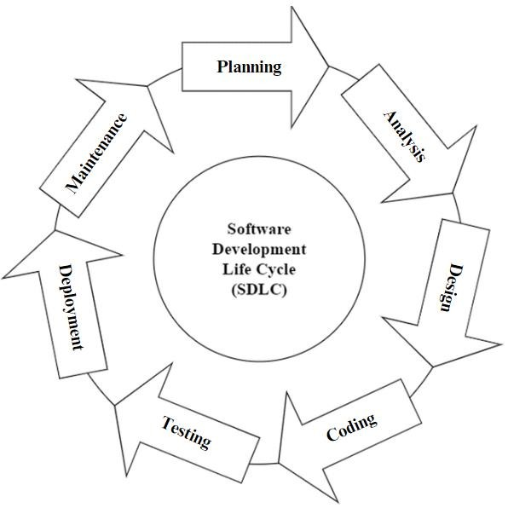

Figure 5.1 : SDLC Life Cycle

The Software Development Life Cycle (SDLC) provides a structured approach to developing software. It encompasses numerous significant stages, from planning and understanding needs, to releasing and maintaining the software. SDLC provides a systematic approach for guiding development. It ensures projects are done efficiently and effectively. The typical SDLC phases include gathering requirements, design, building the software, testing, deployment, and maintenance. These facilitate progress of the project from conception to completion while meeting quality standards and expectations. By following SDLC, organizations can reduce risks, control costs, and deliver highquality software solutions.
5.2 SDLC Process:

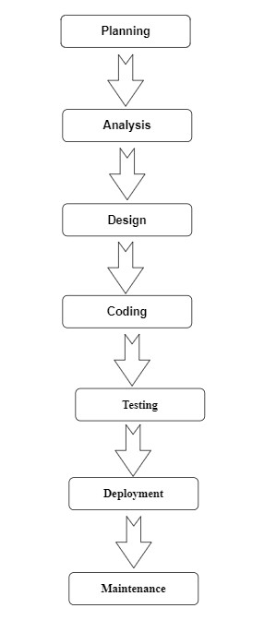
Figure 5.2 : SDLC Process

5.3 Phase in the Software Development Life Cycle (SDLC):

Planning:
During this phase, people involved in the project determine the project's scope, objectives, and requirements. The planning process includes gathering user needs, conducting feasibility studies, and developing a project strategy. Project charters, requirements documents, and initial project schedules are among the key deliverables.Planning phase is crucial in understanding the needs and requirements of the user.

Analysis:
During the analysis phase, the project team thoroughly examines the requirements acquired during the planning stage. This includes determining user demands, specifying system functionalities, and defining system requirements. This phase produces a thorough requirement specification document.Analysis is important in undersatnding what has been planned and to implement it accordingly.

Design:
In the design phase, the system architecture and software design are created using the requirements acquired during the analysis phase. This comprises developing the overall system structure, database architecture, user interface, and software components. System architecture diagrams are among the key deliverables.

Coding :
The implementation step involves creating codes and developing software based on the designs created during the preceding phase. Developers write code, integrate software components, and do unit testing to ensure that individual modules work properly. This phase produces a workable software product that is suitable for testing.

Testing: A crucial stage of the Software Development Life Cycle (SDLC) is testing, during which the program is thoroughly examined to confirm its functionality, dependability, and performance. There are a number of additional factors to take into account throughout the testing process in addition to the testing jobs that have been stated, such as unit testing, integration testing, system testing, and user acceptability testing (UAT).

Deployment: In the Software Development Life Cycle (SDLC), deployment is a crucial stage where software moves from development to live production. Deployment requires meticulous planning and coordination in addition to the technical requirements of configuration and installation to guarantee a seamless transition. This entails carrying out readiness evaluations to confirm that the hardware resources and network connectivity in the production environment are adequate to support the new software.

Maintenance: The Maintenance phase starts after deployment. It entails continuing to support and maintain the software to guarantee its security, functionality, and conformity to changing business requirements. Fixing bugs, dealing with software flaws or problems, improving or adding new features, performance tracking, and optimization to increase system scalability and efficiency are all included in maintenance operations.

5.4 Waterfall Model:
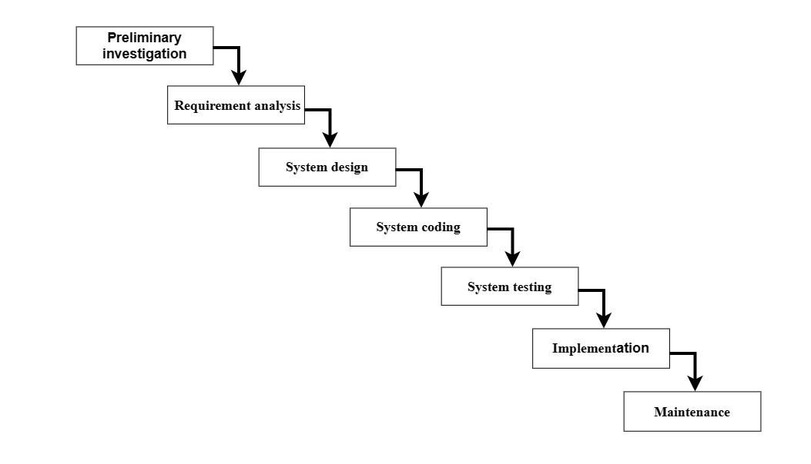

Figure 5.3 : Waterfall Model

In the waterfall model, the process is organized as a cascade of stages, where production one phase plugs into the next phase. Each section is also organized as a set of tasks that may be performed by different people at the same time. as an example of a waterfall specify a sequential linear flow between stages, each stage must provide an output standard of practice.
If the outcome of a stage is poor, it can affect subsequent stages.
Waterfall models are also useful for measuring the progress of a project.
Each stage of the waterfall model represents a specific activity, with progression from stage to stage.At its core, the waterfall model organizes the development process into a series of steps, which typically include requirements gathering, design, implementation, testing, implementation, and maintenance Importantly, . each step must be completed before moving on to the next, with no room for repetition or review once the platform is complete.

5.5 Phases Of Waterfall Model:

- Preliminary investigations: - Preliminary investigations are carried out to find the root cause the problem for which the system should be designed.

- Requirements Analysis: -System and software requirements are listed and review with client.

- System Design: - Once the requirements are understood, the design phase begins. This requires a detailed policy document that outlines software configuration, user, and system components.

- System coding: - In this stage the logical aspects of the design are changed
Machine reading method. The main focus of this step is logical content.

- System testing; - This step in the waterfall model is to detect and check for faults
Defined inputs that can produce expected results.

- Implementation: The implementation phase involves actual coding or programming based on system design. Developers write code according to specifications specified in design documents. This phase focuses on building a software program with coding standards, best practices, and any relevant guidelines.

- Maintenance: - Maintenance step of waterfall model takes care by implementing all types of maintenance of the system such as
  - Corrective maintenance for removal of residual errors.
  - Adaptive maintenance for hardware.
  - Perfective maintenance to enhance the quality of the software.

6. SYSTEM DESIGN

6.1 System Architecture

The diagram depicts the various components and interactions within a women's safety app system, emphasizing features that prioritize user safety and reliable communication in emergency situations.

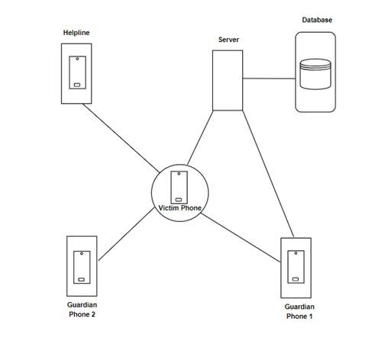

Figure 6.1: System Architecture
6.2 Central Components:

Mobile App (Smartphone):
This is the user interface where victims interact with the app. Key features include a prominent SOS button for triggering alerts, silent guardian mode for discreet alerts, location sharing with emergency contacts, incident reporting with audio/video recording capabilities, and access to a list of emergency resources.

Data Processing and Storage:

Application Server (Cloud):
This central server processes incoming alerts from the mobile app. It verifies user identity, retrieves emergency contact details, and triggers notifications based on user preferences (silent or audible alerts). The server sends SMS or text messages to emergency contacts with the user's location and a help message. Additionally, it may integrate with emergency services APIs for a faster response from police or ambulance services. The server also stores anonymized usage data (e.g., location data with timestamps, types of alerts sent) which can be used for analysis and optimizing resource allocation.

Database (Cloud):
This secure storage system holds user data. Key data points include user ID and authentication credentials, emergency contact information (names, phone numbers, relationships), and user preferences (notification settings, silent guardian mode). Optionally, the database can store medical information if the user chooses to share it. Additionally, anonymized usage data collected from the app is stored for analysis purposes.

6.3 Class Diagram

A class diagram is a structural diagram used in computer science to show a system's static structure by depicting the classes, properties, methods, and relationships between classes. It visually depicts the structure of objects in an object-oriented system, demonstrating how they are organised, interrelated, and interact with one another. Class diagrams are a fundamental tool for creating, documenting, and understanding the architecture of software systems, facilitating stakeholder communication and directing the implementation of object-oriented programming paradigms.
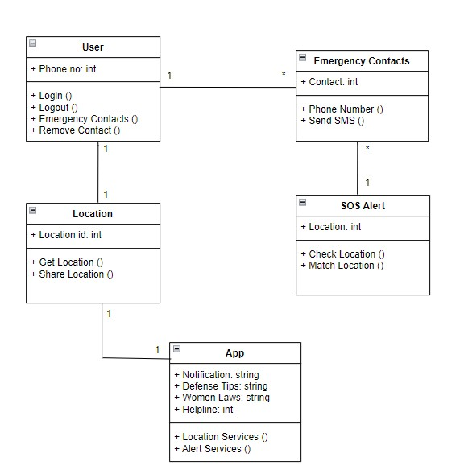

Figure 6.2: Class Diagram
6.4 UseCase Diagram
A use case diagram is a form of behavioural diagram in Unified Modelling Language (UML) that depicts how actors (users or external systems) interact with the system under consideration to achieve certain goals or activities. It gives a high-level view of the system's functions through the eyes of its users, concentrating on the actions they do and the system's responses to those activities.

Use case diagrams are made up of actors, use cases, and their relationships, such as affiliations, generalisations, and includes/extends interactions. They are an effective method for recording and visualising a system's functional requirements, assisting with requirements analysis, stakeholder communication, and system functionality validation.

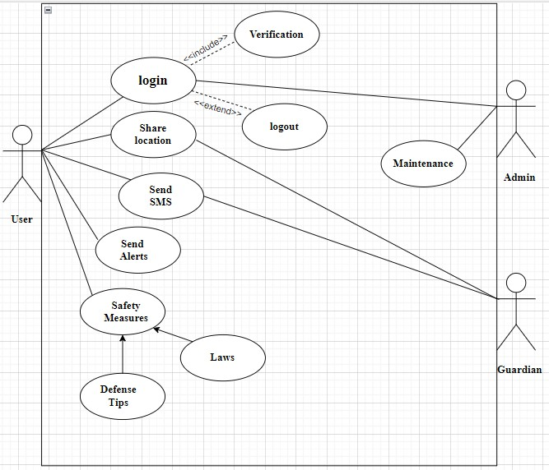

Figure 6.3: UseCase Diagram

6.5 Activity Diagram
In Unified Modeling Language (UML), an activity diagram is a kind of behavioral diagram that shows how actions and activities move through a system or process. It offers a visual depiction of the sequential and concurrent actions taken by objects or actors within the system in order to finish a task or reach a certain objective. Activity diagrams show the steps, decision points, concurrency, and order of steps using a variety of symbols, including activities, joins, transitions, and decisions. They are frequently used to model system behavior, define business processes, and spot possible bottlenecks or workflow inefficiencies throughout the analysis and design stages of software development.

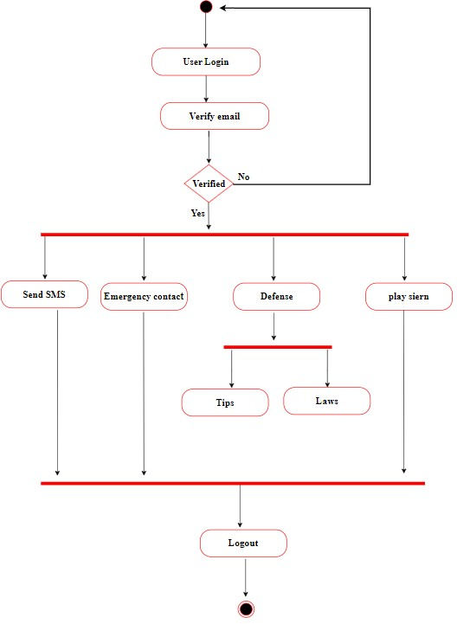

Figure 6.4: Activity Diagram

6.6 Sequence Diagram
In UML, a sequence diagram shows how objects or components interact with one another inside a system. It displays the sequence in which these objects have exchanged messages over time. A vertical lifeline represents each object, and messages are shown as arrows connecting lifelines. Sequence diagrams aid in the understanding of data and control flow within a system by developers. When modeling dynamic behavior and communication patterns in software systems, they are especially helpful. Sequence diagrams can depict method calls, answers, and concurrent activities, as well as basic and complicated interactions between objects. The design, analysis, and documenting of software systems are facilitated by these diagrams.

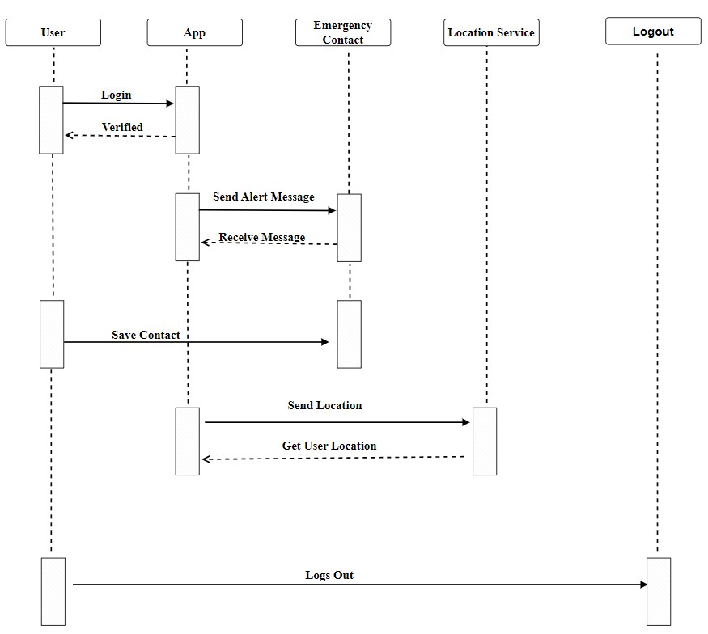

Figure 6.5: Sequence Diagram

6.7 ER Diagram
The relationships between entities in a database are shown visually in entity-relationship (ER) diagrams. It provides an example of a database's structure by demonstrating the relationships between various entities. Relationships between entities are shown as lines connecting them, and entities themselves are represented as rectangles. The attributes of each entity are listed within the rectangle that represents the entity and describe its properties. Relationships between entities can be:
- One-to-One,
- One-to-Many,
- Many-to-Many.

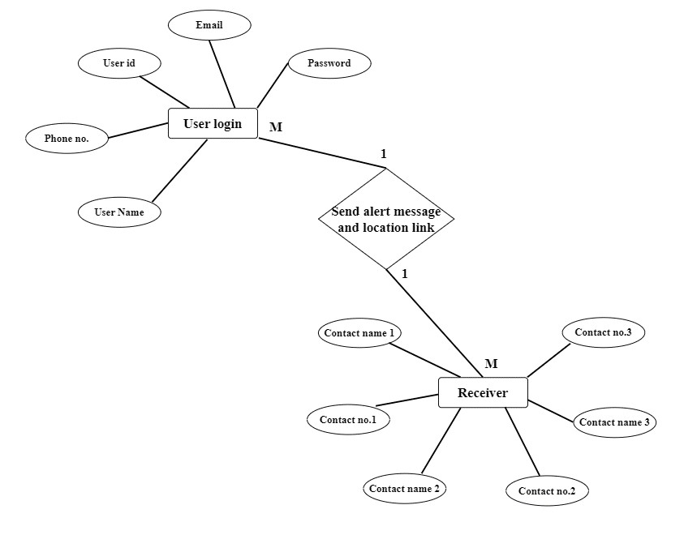

Figure 6.6: ER Diagram

An Overview of Entity-Relationship (ER) Diagram:
- Users: The system stores user information through User entities. It includes attributes like username, email address, phone number, and potentially an emergency contact.
- Login: The login process verifies a user's credentials username and password to grant access to the app's functionalities.
- Contacts: The app allows users to store emergency contact information.
The Contact entity likely stores details like contact name and phone number. There's a many-to-many relationship between Users and Contacts, indicating a user can have multiple contacts, and a contact can be linked to multiple users (i.e., be an emergency contact for multiple people).
- Sending an Alert: The core function of the app seems to be sending an alert message and location to emergency contacts. When a user initiates an alert, the system retrieves the user's information and retrieves contact details linked to the user's emergency contact .
- The ER diagram represents a simplified model of a women's safety app that focuses on user login, contact storage, and the emergency alert functionality.

User Login and Sending an Alert:
- This is a one-to-many relationship.
- One User: This represents a single user of the app who logs in with their credentials username and password.
- Many Alerts: This user can send multiple alerts in case of emergencies.
2. Alert and Receiver Relationship:
  - Another is one-to-many relationship.
  - One Alert: This represents a single alert message sent by a user.
  - Many Receivers: This alert message can be sent to multiple emergency contacts chosen by the user.

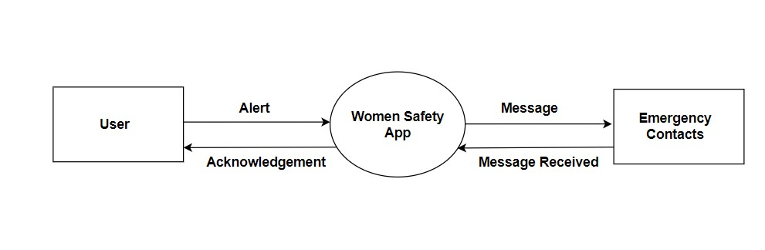
6.8

DFD Diagram
-

Level 0

Figure

6.7
:
Zero Level Data Flow Diagram

Central Process: Women's Safety App

•

This is the heart of the system, represented by the large circle in the center. It
encapsulates all the functionalities and processes happening within the Women's
Safety
App.

•

Internally, the app might have various sub
-
processes for handling different tasks, like:

•

Managing user accounts and authentication.

•

Processing alerts and triggers based on user actions (SOS button, silent
guardian mode, incident reporting).

•

Accessing and displaying emergency resources (helplines, police stations,
shelters).

•

Utilizing GPS data to determine user location for emergency purposes.

•

Sending notifications and alerts to emergency contacts via SMS, text
messages, or other communication channels.

•

Optionally, integrating with emergency services APIs for faster response.

  - External Entities:

  - User: This represents the individuals who have downloaded and registered with the Women's Safety App.
  - Users interact with the app through its interface, initiating various actions like:
  - Triggering alerts (SOS button, silent guardian mode).
  - Reporting incidents with details and potentially audio/video recordings.
  - Viewing emergency resources and safety information.
  - Managing emergency contact information.

  - Emergency Contacts: These are the people designated by the user to receive notifications or requests for help in case of an emergency. They can be:
  - Family members.
  - Close friends.
  - Emergency service providers (police, ambulance) - depending on the app's capabilities and local regulations.

Data Flows:
  - Alerts (User to App): This arrow depicts the flow of data from the user to the app. It represents user actions that trigger an emergency response or request for help:
  - Pressing the SOS button.
  - Activating silent guardian mode.
  - Reporting an incident with details like text, audio, or video recording.
  - Choosing to share their location with emergency contacts.

 | DefendHER- Women Safety Android Application
•  • | Information (App to User): This arrow shows the app providing information back to the user. This could include:  - Confirmation of a received alert and ongoing processing.  - Estimated arrival time of help (if integrated with emergency services).  - Displaying relevant safety tips based on the user's situation.  - Presenting a list of nearby emergency resources based on the user's location.  - Updates on the status of their sent alert or incident report.  Information (App to Emergency Contacts): This arrow represents the app sending information to the user's designated emergency contacts in case of an alert. The data flow might include:  - User's current location information for quicker assistance.  - A pre-programmed message requesting help or indicating danger.  - Additional details from the user's incident report (if applicable).  63

6.9 DFD Diagram- Level 1

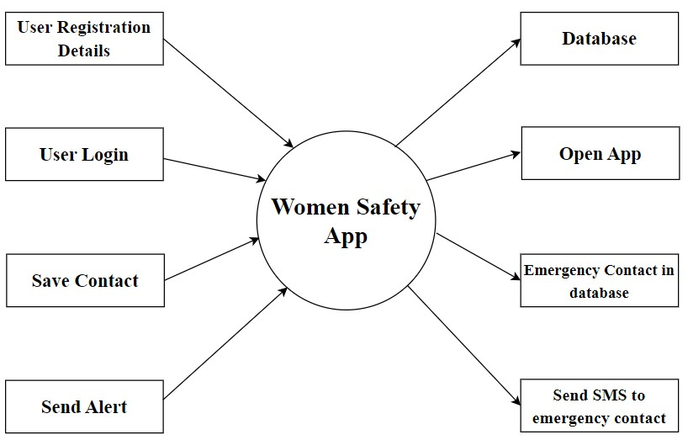

Figure 6.8: First Level Data Flow Diagram

A Data Flow Diagram (DFD) Level 1, builds on the high-level picture provided by a Context Diagram (DFD Level 0. It focuses on decomposing the single process in the Context Diagram into its major sub-processes. This level goes deeper into the system, revealing the functional components that collaborate to achieve the primary objective.

Within a Level 1 DFD, processes are represented by circles, data flows by arrows, and data stores by rectangles. The processes describe the system's basic operations, whereas data flows show how information is exchanged between these processes and other entities. Data stores serve as repository for information used by all processes in the system.

User Registration:
The process begins with user registration. During registration, the user enters their details which are stored in a database.

User Login:
Once registered, the user can log in to the app with the details The app verifies these credentials against the stored user information in a database which will lead to successful login in the app.

Save Contact:
The user can save emergency contact information within the app. These contacts would be people the user wants to be notified in case of an emergency. This information is stored alongside the user's details in the database.

Send Alert:
If the user feels unsafe, they can send an alert through the app. The users can use the SOS Button, Send SMS to Emergency Contacts, and notify them with their current location.

Send SMS to Emergency Contact:
Upon receiving an alert, the app automatically sends an SMS to the user's emergency contacts, presumably notifying them of the user's situation and potentially including the user's location.

7. MODULES

1. Emergency Contacts:

- Adding and Managing Contacts:
Users can add phone numbers, email addresses, and even relationships (mom, dad, best friend) for each contact.
- Quick Dial:
With a tap or swipe, users can directly initiate a call, text message, or even share their location with an emergency contact.

- SOS Alert:

  - Action Trigger:
This can is a dedicated button, a shake gesture, or a combination that is used to initiate an alert.
  - Alert Content:
    - Pre-written message with user's location sent to emergency contacts.
    - Option to customize the message for specific situations.
  - Emergency Call:
Connecting directly to pre-programmed emergency services or a designated helpline.

  - Silent Mode:
Option to send a silent notification to contacts without alerting the user's surroundings (flashing light or vibration).

- Real-time Location Tracking:

  - Sharing Options:
Allow users to share their location:

Privacy Settings: Users can tailor their sharing preferences based on specific contacts or groups, allowing them to control who can view their real-time location . This feature provides flexibility and ensures privacy while still enabling users to share their whereabouts with trusted individuals when needed.

    - Upon activating the SOS alert:

In case of an emergency, this is the best solution.
The program notifies emergency contacts of the user's current location when they press the SOS button.

This is an efficient method of sharing location during an unexpected incident without having to track all the time.

- Self-Defense Resources:

  - Content Library:
It includes articles, or interactive tutorials on basic self-defense techniques.
  - Situational Awareness Tips:
Provide guidance on how to identify and avoid potentially risky situations an be aware about all that it happening around.
  - Emergency Response Plans:
The app can offer advice on what to do during different types of emergencies which would help the users to get immediate assistance and also be aware about the surroundings and also educate others regarding the same.It will help the users to react quickly and swiftly in times of need.

- Emergency Services Directory:

  - Local Emergency Hotlines:
The app should includes contact information for police, women helpline, emergency numbers , and other relevant important helplines that will ensure that users have access to emergency phone numbers for their immediate assistance.

8. GANTT CHART

8.1 Gantt Chart Table:

Development Task | Start Date | End Date | Duration
Application Blueprinting | 07-02-2024 | 14-02-2024 | 8 Days
Resource Accumulation | 15-02-2024 | 19-02-2024 | 5 Days
Application Design | 20-02-2024 | 05-03-2024 | 15 Days
Testing | 06-03-2024 | 10-03-2024 | 5 Days
Coding | 11-03-2024 | 13-03-2024 | 34 Days
Final Testing | 14-04-2024 | 20-04-2024 | 7 Days

Figure 8.1: Gantt Chart Table

8.2 Gantt Chart Graph:

This horizontal bar chart displays the development timetable for a women's safety app. Each bar represents a development stage, such as Application Design , Testing, etc and its length indicates its duration. The x-axis depicts task durations, while the y-axis shows the tasks themselves. This graphic depicts a rapid visual summary of the project timeline.

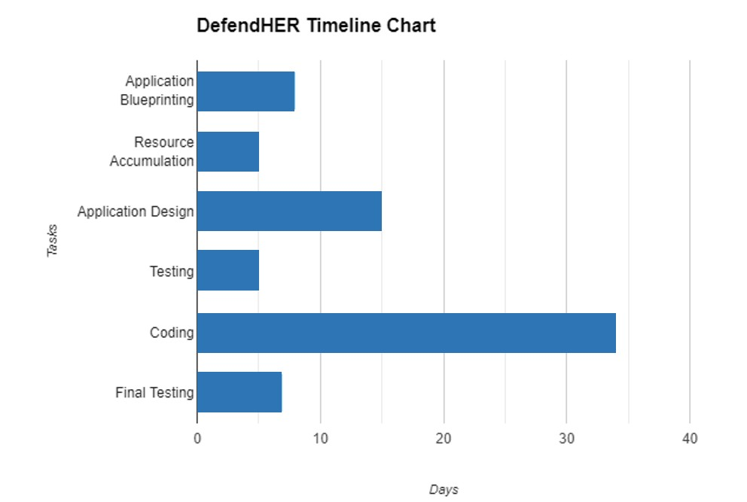

Figure 8.2: Gantt Chart Timeline Graph

9. APP PREVIEW

- Onboarding Screen:

Welcome To Women Safety App:
These images represent Onboarding Screen of the application

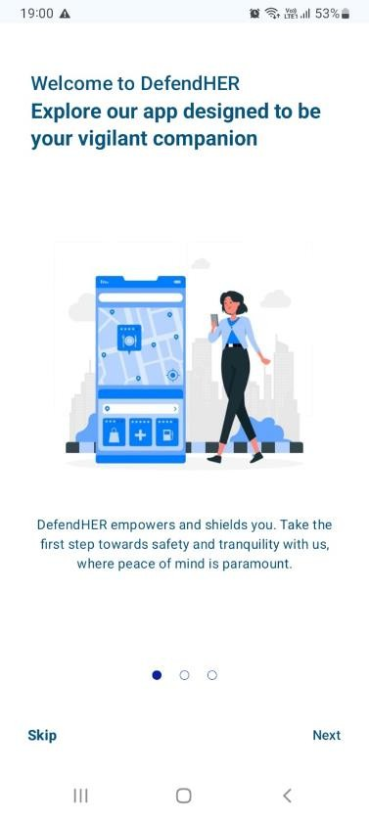
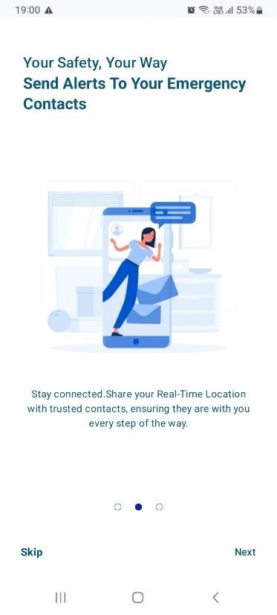
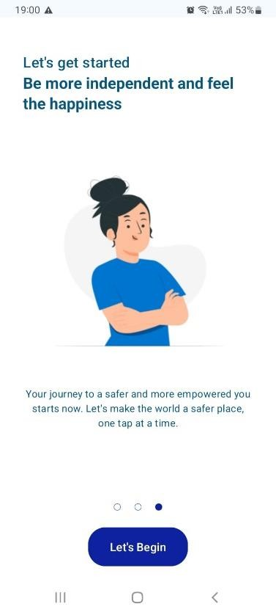

Figure 9.1: Onboarding Screenshot

- Login Page:

Sign Up allows users to create an account so that they can access the features and functionality of the app.
Users first need to register with their details and verify themselves.

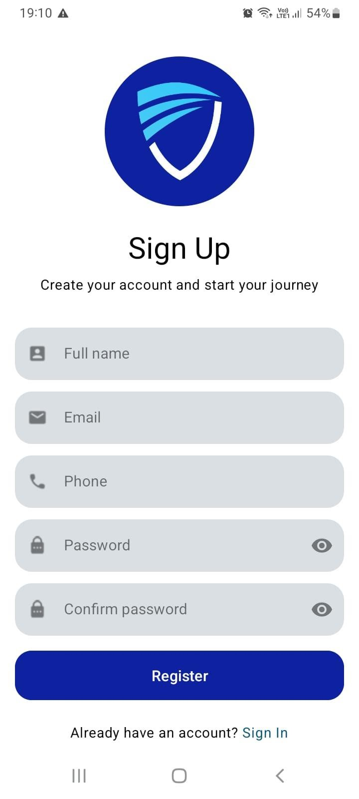
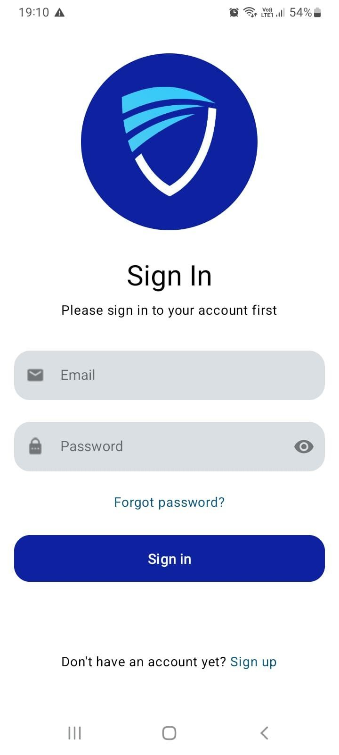

Figure 9.2: Login page

- Verification Page:

A message informs the user that an email has been sent to the mail address. Instructions are provided to click on a link in the email to complete the signup process. In case the user cannot find the email, they are advised to check their spam folder.

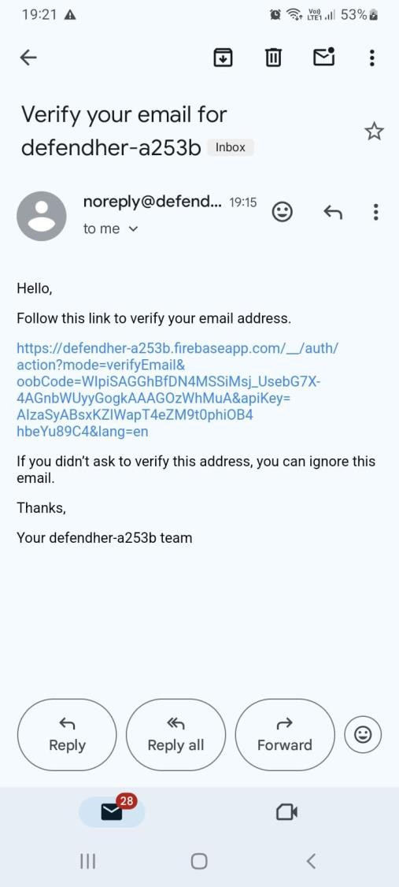
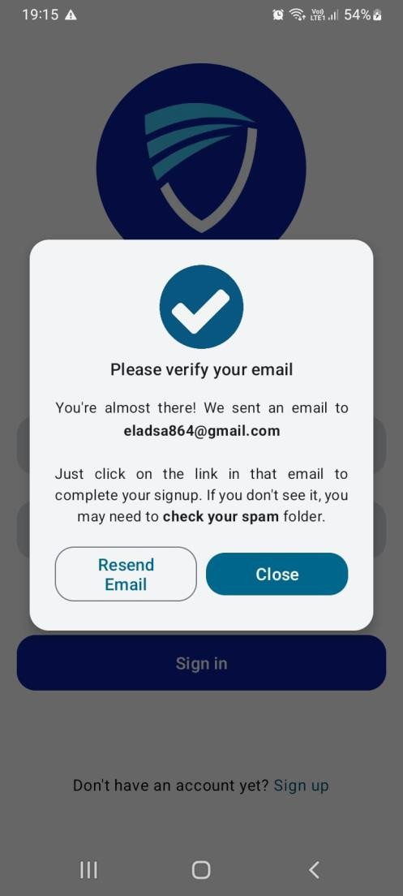

Figure 9.3:Verification page
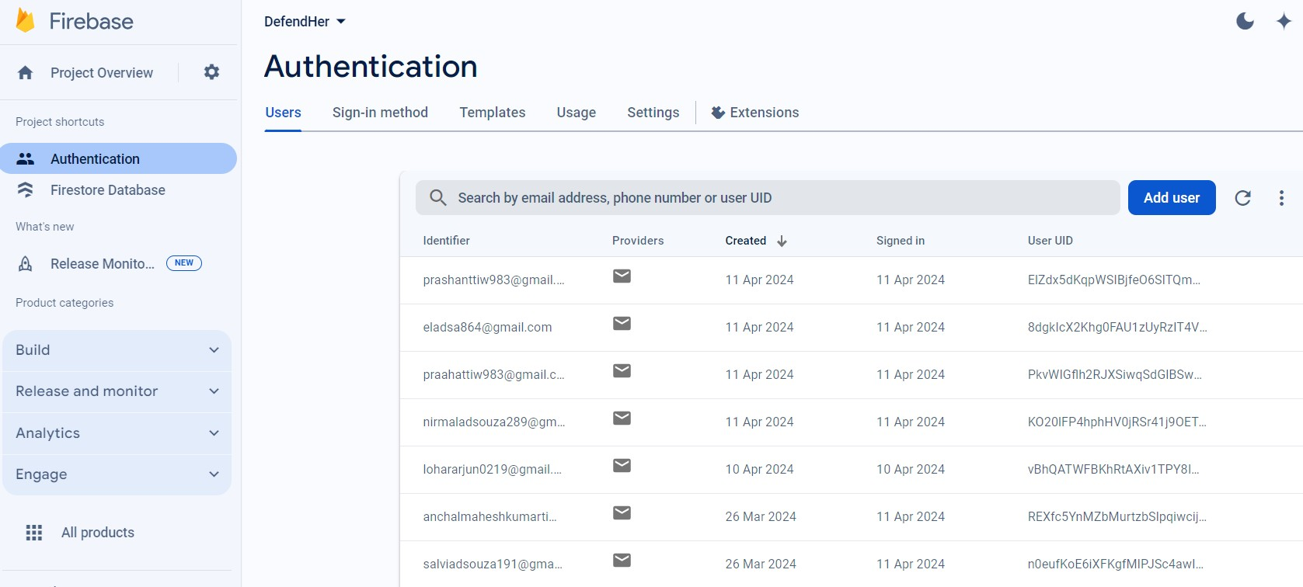
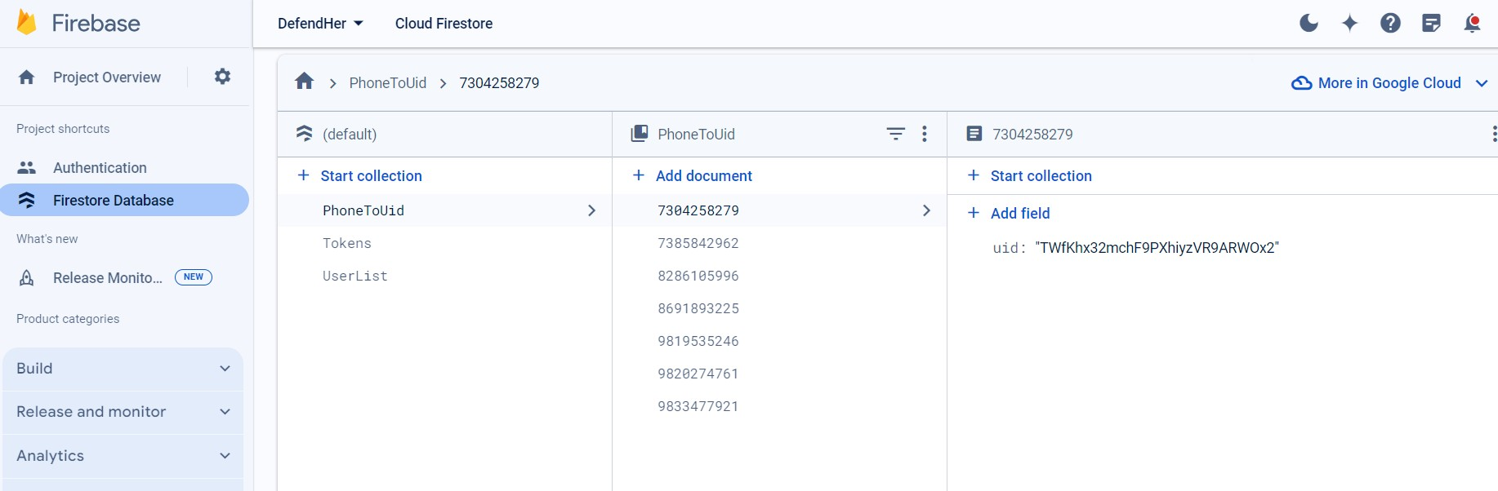

4
.
Firebase Database:

These images show Firebase project user authentication page. It shows a list of users with
their email addresses,
creation dates, last sign in dates, and unique identifiers

along with the
project dashboard.

Figure
9
.
4:

Database
5. Home Page:
This screen represents the homepage which has an
- SOS button
- Emergency Contacts
- Helpline
- Safety Tips & Laws
- About

When the SOS Button is pressed it allows to play the siren, send SMS to emergency contacts and shake detection services.

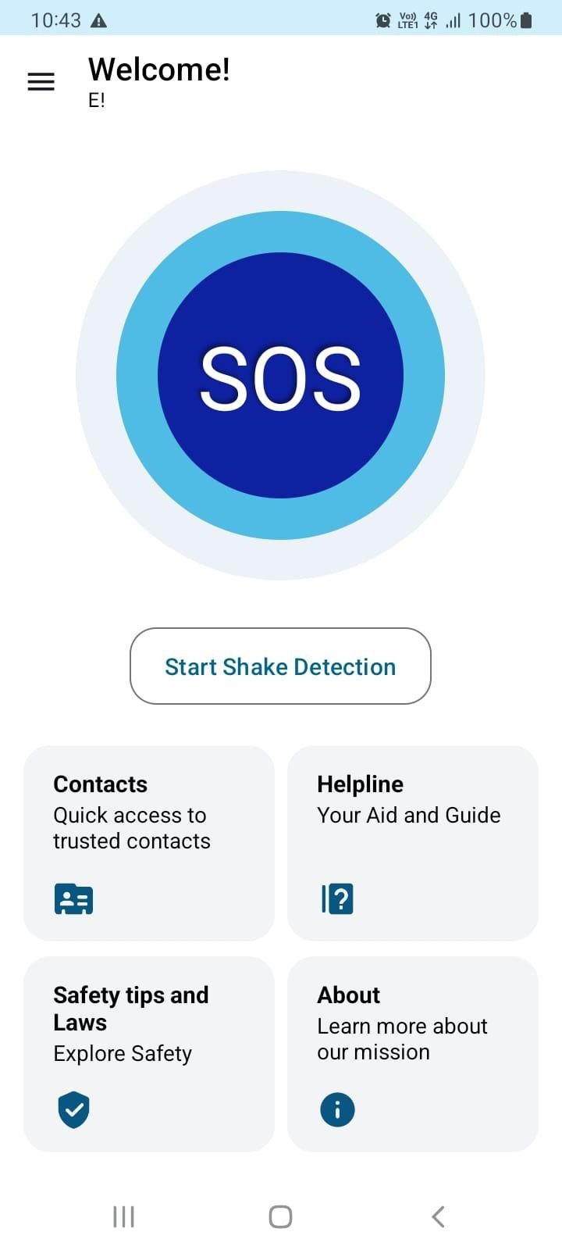
Figure 9.5: HomePage
  - Emergency Contacts Page:

The contacts list allows users to store information about the people they can contact in case of emergency and when the press the SOS Button then a location will be sent to this number via SMS.

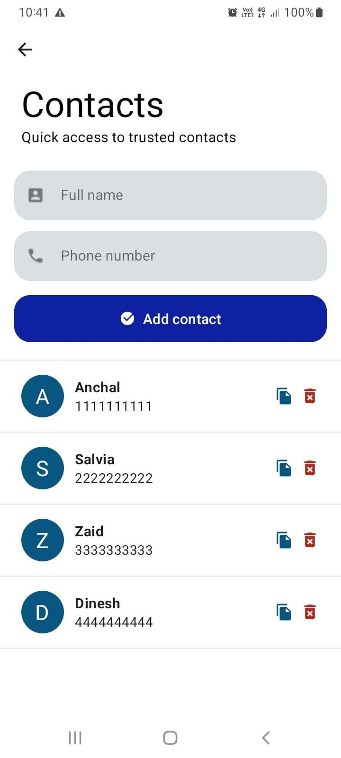

Figure 9.6: Emergency Contacts

  - SMS Alert:

When user presses SOS Button, a notification will be sent to the contacts and location link will be shared.

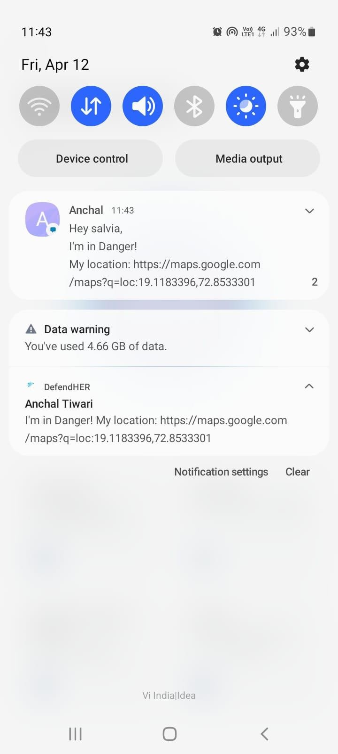
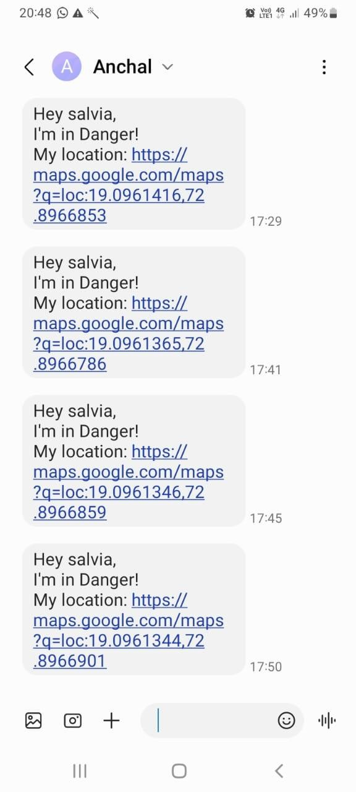

Figure 9.7 Alert Message
  - Location:
This image represents the current location of the victim that is sent to the contacts that are present it the emergency contact list so that they can track the victim’s current location.

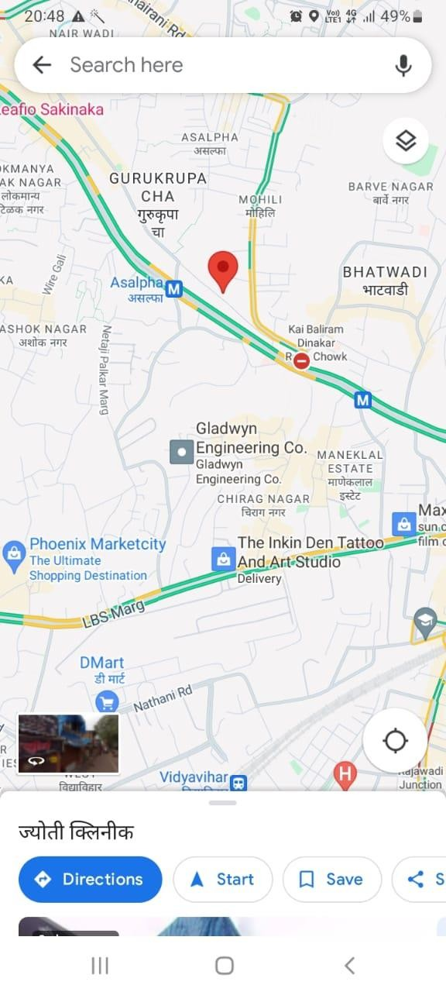

Figure 9.8: GPS Location

  - Helpline Page:
This section includes all the helpline numbers that will help in case of emergency and the victim can contact them and get immediate help.

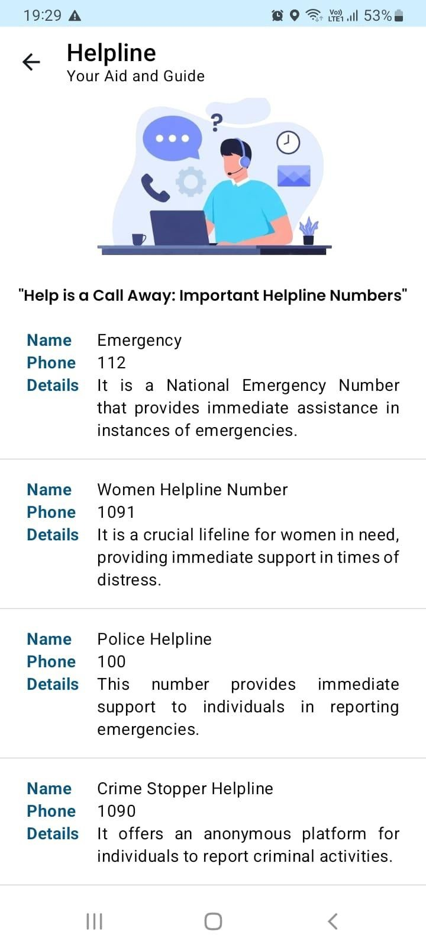

Figure 9.9: Helpline
  - Self-defence Page:

This section includes defense tips that will help users to become aware and to increase selfconfidence and how face an unsafe situation.
It also has a set of Laws which will make the users aware about their rights and powers.

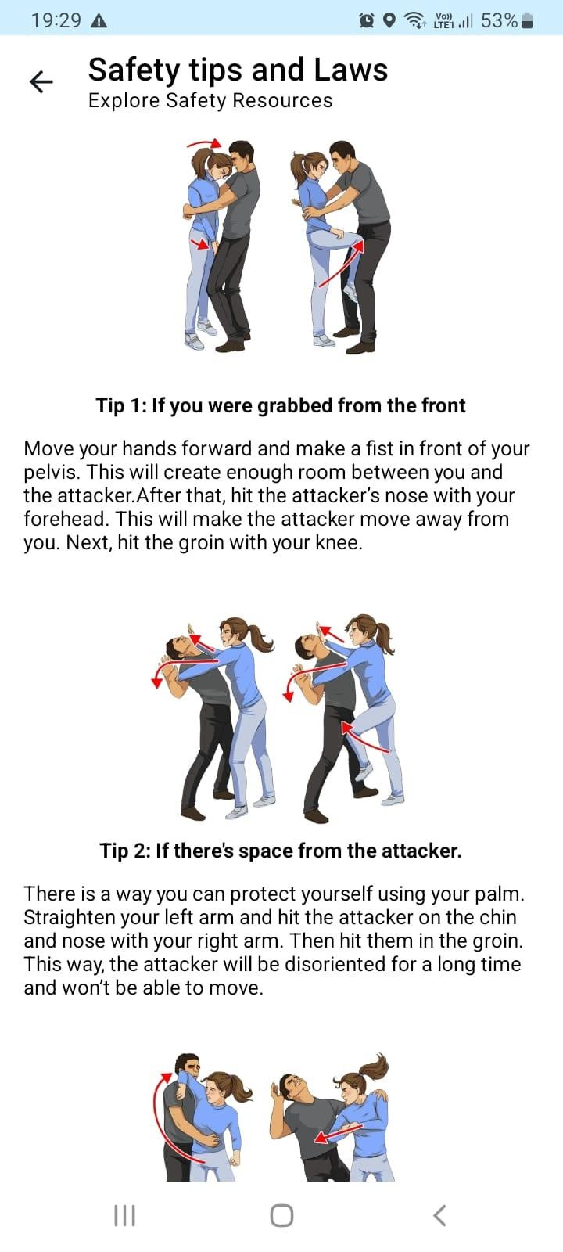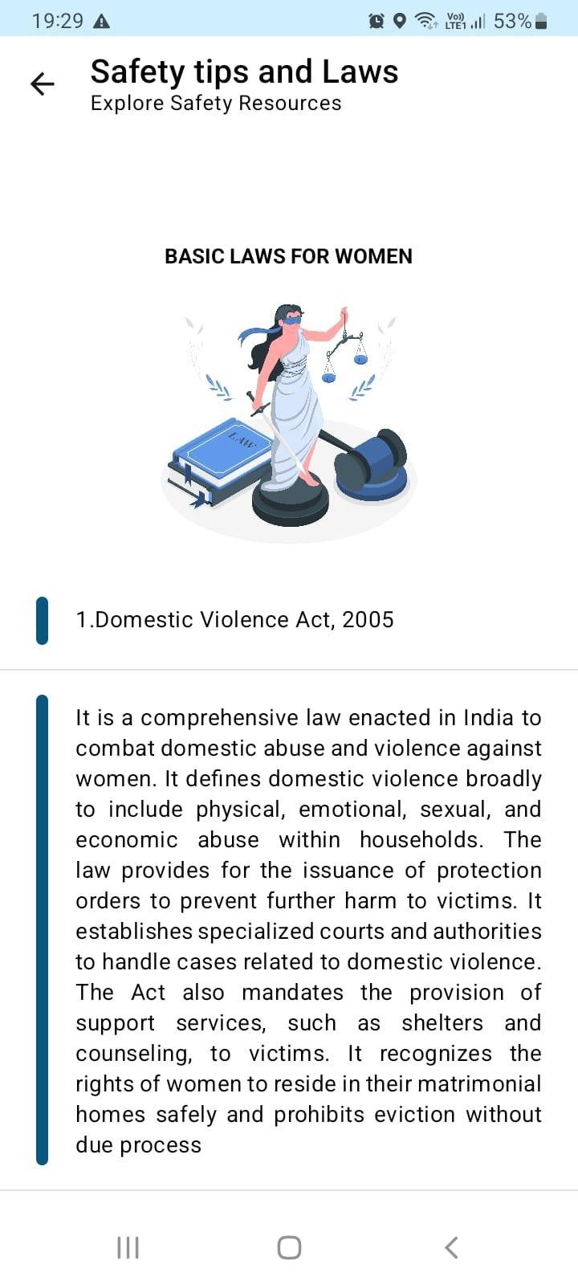

Figure 9.10: Tips & Laws
  - Navigation Drawer:

This represents a Navigation Drawer which includes Profile, Settings & Logout function.
Users can Edit their profile, Manage settings and Logout of the app.

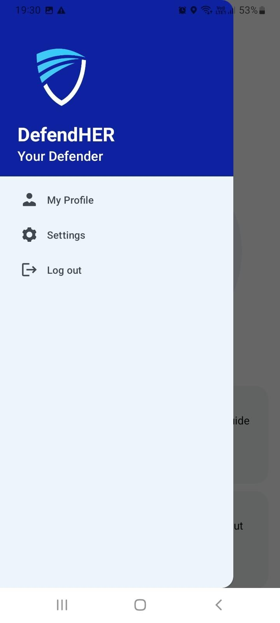

Figure 9.11: Navigation Drawer

  - Profile Page:

In My Profile page, Users can view their profile i.e details and also Edit their Profile.

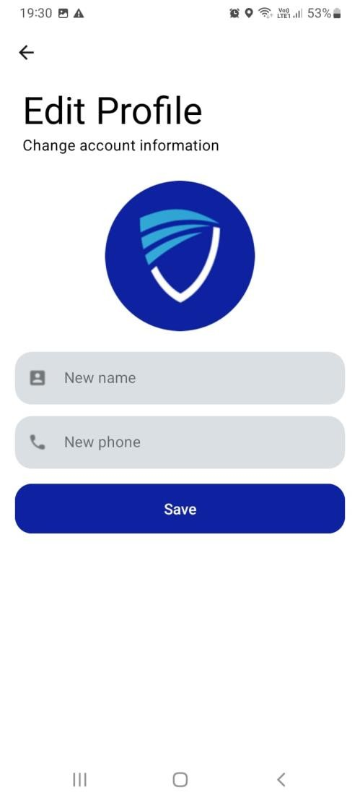
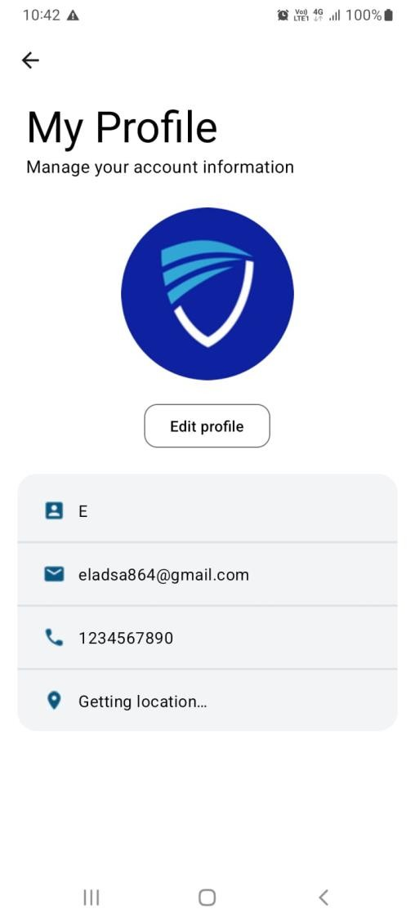

Figure 9.12: Profile

  - Settings:

The Settings Page includes the following:
- Shake detection: This feature allows users to send an SOS by shaking their phone.
- Send SMS: This feature allows users to send an SOS message via SMS and notification.
- Play siren: This feature allows users to play a fake police siren at full volume in emergency mode.
- Call emergency service: This feature allows users to automatically call national emergency services.
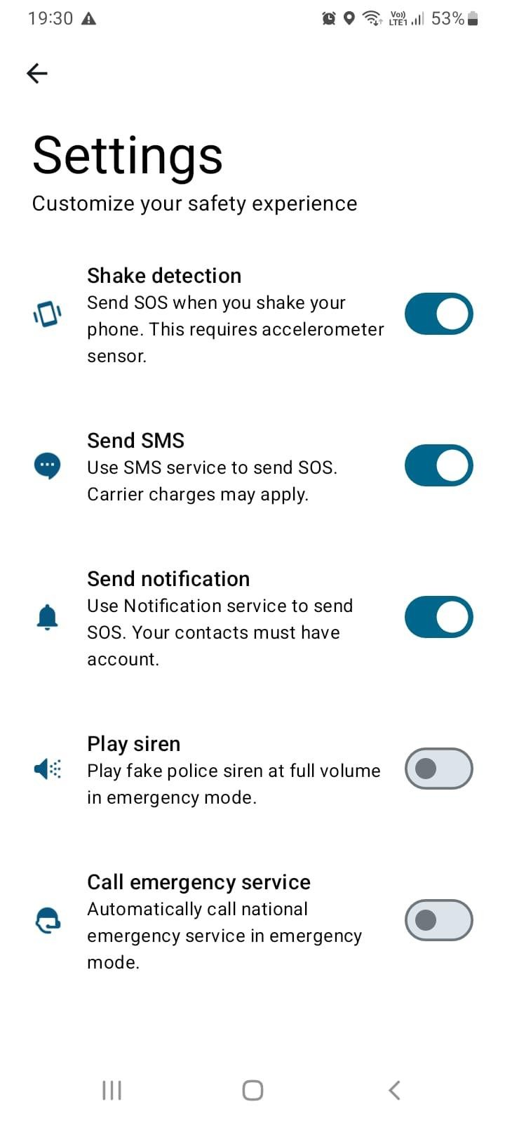
Figure 9.13: Settings

10. FUTURE PROSPECTS

1. Community Engagement Features:

- Community Alert:
Permit users to report occurrences of suspicious activity or crimes they witness nearby. This can be completed anonymously and contribute to the development of an awareness network among users.

- Safety forums:
Create a place for users to share safety tips, discuss concerns, and get support from other women. This can create a sense of community and empower users.

- Volunteer Networks:
Enable users to make connections with volunteers who are prepared to provide them with a listening ear, take them home at night, or accompany them to public locations. This can add a crucial element of security, particularly for people who don't feel comfortable venturing out by themselves.

2. Artificial Intelligence for Personalization and Safety:

- Personal security systems:
Use AI to analyze user behavior, routines, and location data to identify potential risks and suggest personal security recommendations.

- Smart Threat Detection:
Create AI algorithms that can scan the user’s surroundings using the phone’s camera and microphone to identify potential threats. This may include identifying weapons, suspicious characters, or aggressive language.

- Predictive Safety Alerts:
AI is used to identify potential dangers for a user and provide warnings in advance. For instance, the app might notify a user to reveal their position or initiate a fictitious call if they happen to be strolling through a known crime hotspot at night.

3. Chatbot for Support and Guidance:

- 24/7 Safety Assistant:
Implement a chatbot that users can contact at any time for safety tips, incident reports, or simply for emotional support. This can be especially helpful for users who are uncomfortable calling the emergency services or have no one to talk to.

- Security Information Recovery:
Build a chatbot that can answer users’ questions about security features, defense mechanisms, or legal procedures after an attack. This makes it easier for users to access important information in real time.

10. LIMITATIONS

- Dependence on Technology:
Women’s safety apps are valuable tools for improving personal safety, but their effectiveness depends on smartphone reliability and network connectivity where the user’s phone battery suddenly runs out or app performance can suffer as they have critical network constraints, any interruptions in network connectivity or equipment failures can severely hinder the application’s ability to provide timely alerts or calls for help. This reliance on technology highlights the importance of users focusing on network availability to maintain their devices in optimal conditions, especially in environments that are sensitive to signals that will interfere or have fewer interactions, making women’s safety measures more effective.

- False Alarms:

Although women's safety apps are made to offer a prompt and efficient reaction during emergencies, false alarms can still happen from time to time. Accidental touches or misunderstanding app features might cause users to mistakenly trigger emergency alarms, which could cause needless panic and put a burden on emergency response resources. Additionally, a high amount of notifications that turn out to be non-urgent can cause authorities to get used to true emergencies due to the predominance of false alarms. This desensitization is dangerous because it could lead to insufficient or delayed reactions to actual emergencies, endangering the security of those who are most in need. The impact of false warnings should be reduced by women's safety applications having elements like confirmation.

 | DefendHER- Women Safety Android Application
•  • | Limited coverage:  Women’s safety apps may not work well in all environments, especially in areas with poor network connectivity or limited access to emergency services. In remote or rural areas, where infrastructure and telecommunications networks are  underdeveloped, women’s safety systems may struggle to function effectively due to unreliable internet connectivity or lack of mobile phone access, therefore, This restriction poses significant challenges to individuals living in these areas, due to the availability of safety measures needed in an emergency Resources and availability may be unavailable Furthermore, where emergency services are scarce or are inaccessible, women’s safety services may not be able to provide timely support or communication with local authorities, leaving users vulnerable to long-term distress and uncertainty.  Response Time:  Women's safety apps are a useful tool for notifying emergency services or designated contacts in an emergency, but how well they work in emergencies depends on several variables, such as the user's location accuracy and the accessibility of emergency services. The possibility of getting a timely and wellcoordinated response to alerts issued by women's safety apps may be higher in crowded urban regions with established emergency response systems than in rural or remote areas with limited or non-existent emergency services. Furthermore, users' overall response times may be impacted by emergency dispatch centers’ ability to manage incoming alerts and prioritize response efforts.  87

 | DefendHER- Women Safety Android Application
•  •  •  •  •  • | 11. CONCLUSION  In conclusion, DefendHER stands as a powerful tool in championing women's safety, offering a comprehensive suite of features designed to empower and protect. By seamlessly integrating real-time tracking, emergency alerts, and Self-defense Tips.  It is more than an app; it's a guardian, providing a sense of security in every pocket. As we navigate the digital landscape of safety, It remains committed to its mission of ensuring the well-being and confidence of every user.  DefendHER—a steadfast companion in your journey toward a safer, more secure future.  Let’s continue illuminating our way forward.  It is unwavering in its aim to protect everyone's safety in the face of ever changing safety risks. With constant support and effort, It illuminates our path forward as we continue to navigate towards a safer and more secure future. Together, let's maintain everyone's safety and sense of empowerment.  It is a change-catalyst, not just a safety app. It creates a cascading effect when women are provided with the means and instruments necessary to maintain their safety. Broader discussions about safety and prevention might be sparked by heightened awareness and a feeling of community. As more women feel comfortable going out into the world, the status quo is challenged and a future where everyone may feel confident and free is paved  It is an appeal to establish a society in which everyone has the right to safety rather than seeing it as a privilege. Together, let's pave the way for a more promising and secure future for everybody.  88

DefendHER- Women Safety Android Application

10. REFERENCES

- AbhiRaksha: Advanced Women Safety App. Behance.
https://www.behance.net/gallery/93648247/AbhiRaksha-Advanced-Women-Safety-
App

- Crime Against Women in India: A Look at NCRB Report 2023. NewsClick.
https://www.newsclick.in/crime-against-women-india-4-ncrb-report-2023

- Srinivas, K., Gothane, S., Krithika, C. S., Anshika, & Susmitha, T. (2024). Android App for Women Safety. International Journal of Scientific Research in Computer Science,
Engineering and Information Technology, 24(5), 378. https://doi.org/10.32628/CSEIT1217368

- diagrams.net. https://app.diagrams.net/

- Google Gemini. https://gemini.google.com/app

- Blackbox.ai. Expert Android Chat. https://www.blackbox.ai/chat/expert-android\

- FreePik: Images, Illustrations, Icons: https://www.freepik.com/

- Wikipedia (Violence against Women in India):
https://en.wikipedia.org/wiki/Violence_against_women_in_India

89

DefendHER- Women Safety Android Application

- Bright Side (Self-defence Techniques for Women Article):
Bright Side. 7 Self-Defense Techniques for Women Recommended by a https://brightside.me/articles/7-self-defense-techniques-for-women-recommended-bya-professional-441310/

- YouTube Video Reference:
URL: https://www.youtube.com/watch?v=NkE4sxeAfFE&t=170s

- National Commission for Women (List of Laws Related to Women):
http://ncw.nic.in/important-links/List-of-Laws-Related-to-Women

- National Crime Records Bureau: https://ncrb.gov.in/

90

